**ENSEMBLE MODELS**

WHAT ARE ENSEMBLES ?

PART 1 : BOOTSTRAPPED AGGREGATION (BAGGING) INTUITION

RANDOM FOREST AND THEIR CONSTRUCTION

BIAS - VARIANCE TRADEOFF

RUN-TIME AND TRAIN COMPLEXITY

EXTREMELY RANDOMIZED TREES

CASES IN RANDOM FORESTS

PART 2 : BOOSTING INTUITION

RESIDUALS, LOG-LOSS AND GRADIENTS

GRADIENT BOOSTING

REGULARIZATION AND SHRINKAGE

TRAIN AND RUN TIME COMPLEXITY

ADABOOST

STACKING MODELS

CASCADING CLASSIFIERS

# **WHAT ARE ENSEMBLES ?**

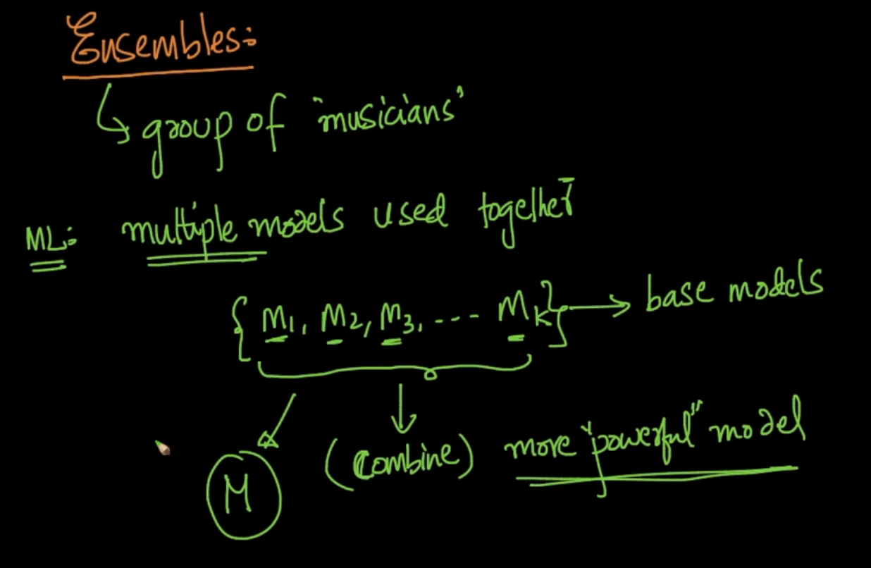

Ensembles : A group of Things . In the Machine Learning world it means using multiple models together i.e {$M_{1},M_{2}.....M_{k}$} these are base models like Logistic Regression, SVM and we combine them and try to take all the good properties of them and make a more powerful model ‘M’

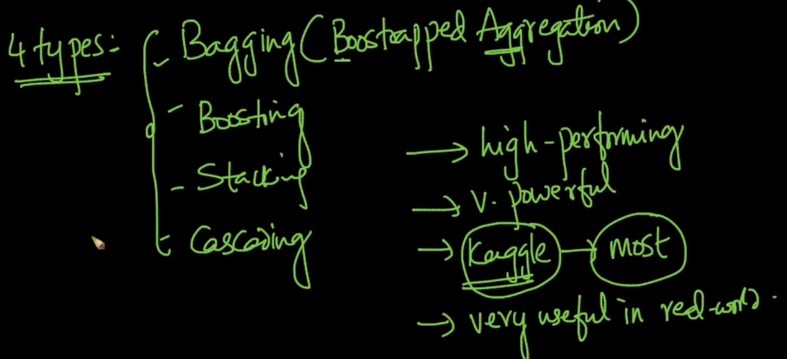

These are 4 types of Ensemble models

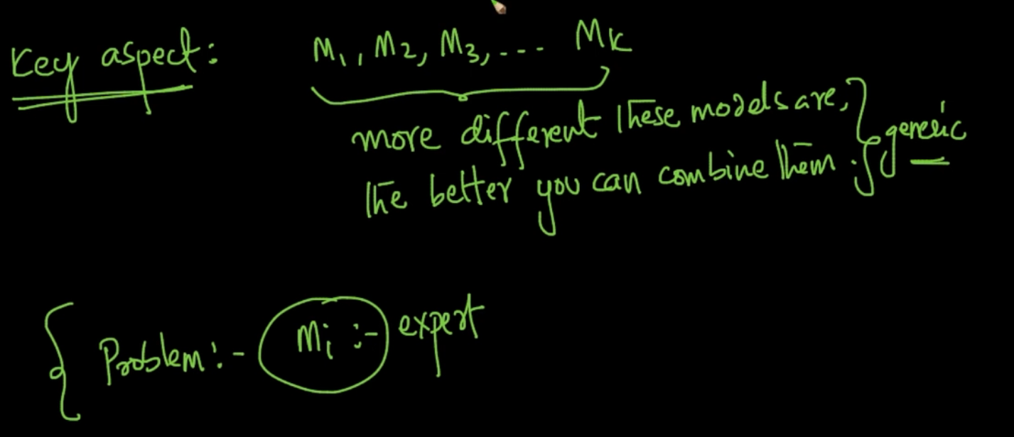

One of the key aspect is {$M_{1},M_{2}.....M_{k}$} the more different these models are the better you can combine them. Think of it as Experts of different fields and we are getting results using the combination of their opinions

# **PART 1 : BOOTSTRAPPED AGGREGATION (BAGGING) INTUITION**

Bagging comes from B - Bootstrap, Agg - Aggregation . From our Train Data $D_{n}$ we take samples and make a model from samples from $D_{n}$. Suppose we are taking ‘k’ samples all with m points and make k no. of models. Now we combine these models which is called aggregation of models and make a model M

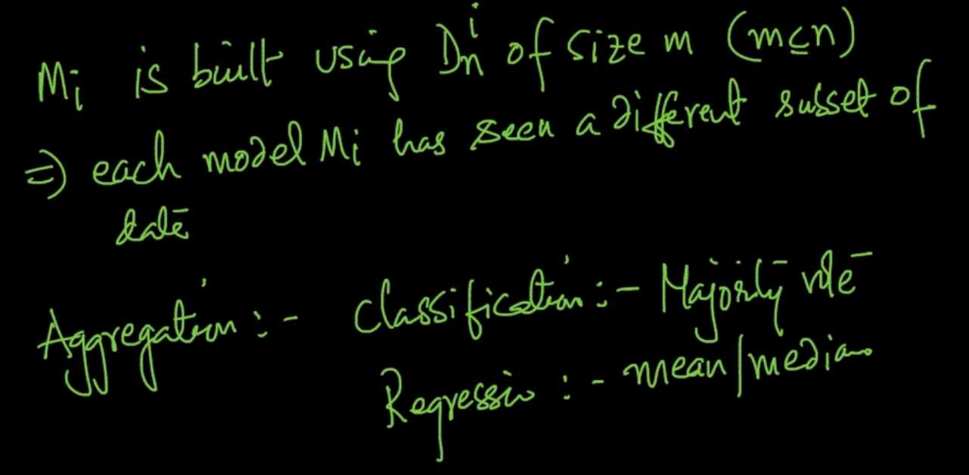

Each model sees a different subset of data.

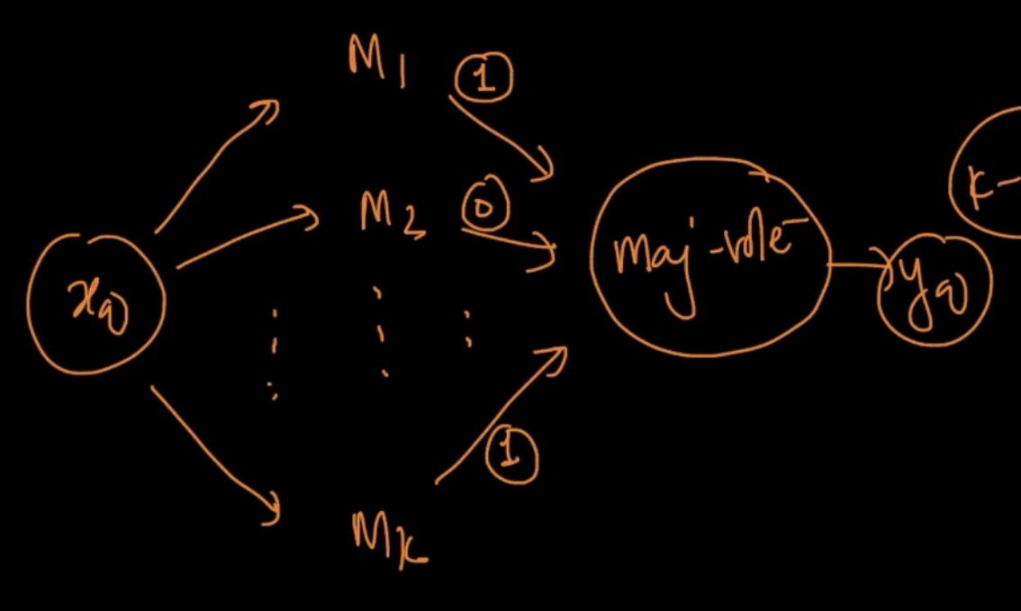

**Classification :-** If a new query $x_{q}$ comes we pass it to all the models and they predict labels i.e let’s say model ${M_{1}}_{}$ => 1, $M_{2}$ => 0….. $M_{k}$ => 1 and if majority gives 1 then $y_{q}$ = 1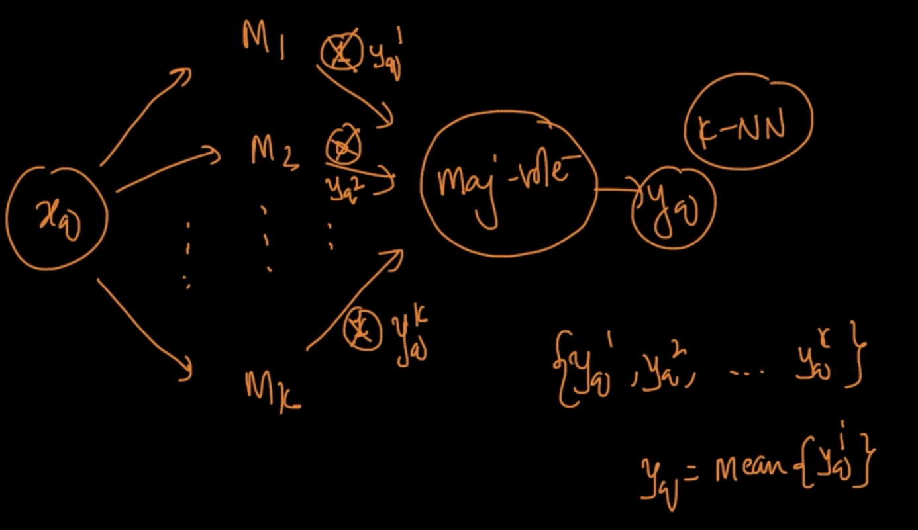

**Regression :-** If a new query $x_{q}$ comes we pass it to all the models and they predict labels i.e let’s say model ${M_{1}}_{}$ => $y_{q}^{1}$, $M_{2}$ => $y_{q}^{2}$….. $M_{k}$ => $y_{q}^{k}$ and we store {$y_{q}^{1}$, $y_{q}^{2}$,..., $y_{q}^{k}$} then we take the mean of all the predicted $y_{q}$. So, $y_{q}$ = mean {$y_{q}^{i}$}

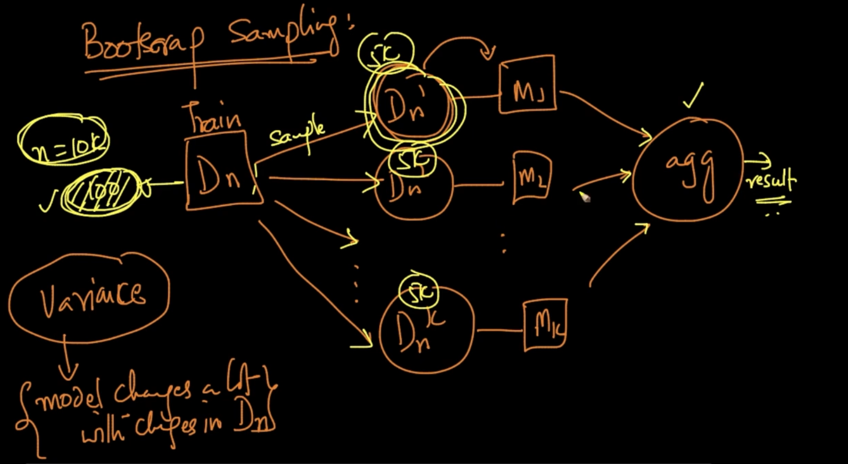

We’ve n = 10k points. We take 5k points randomly in our samples for creating models

We say Variance of a model is high if model changes a lot in with changes in Train Data.

So if 100 points are changed then in our Bagging pipeline not all the samples will have these 100 changed points, only some so with majority vote our final result isn’t getting impacted much. This is the core idea of Bagging

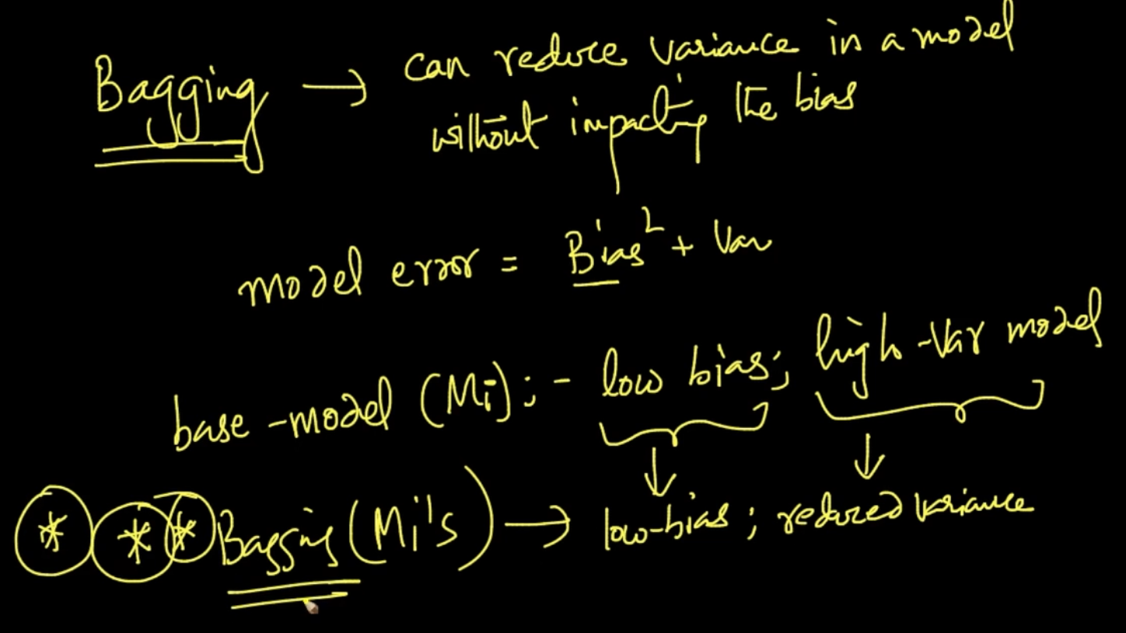

The above theory implies that Bagging can reduce variance in a model without impacting bias. Model Error : ${Bias}^{2} + Variance$. If our Base models ($M_{i}$) are low bias, high variance models then with Bagging on $M_{i}'s$ we’ll still have low bias and also reduced variance

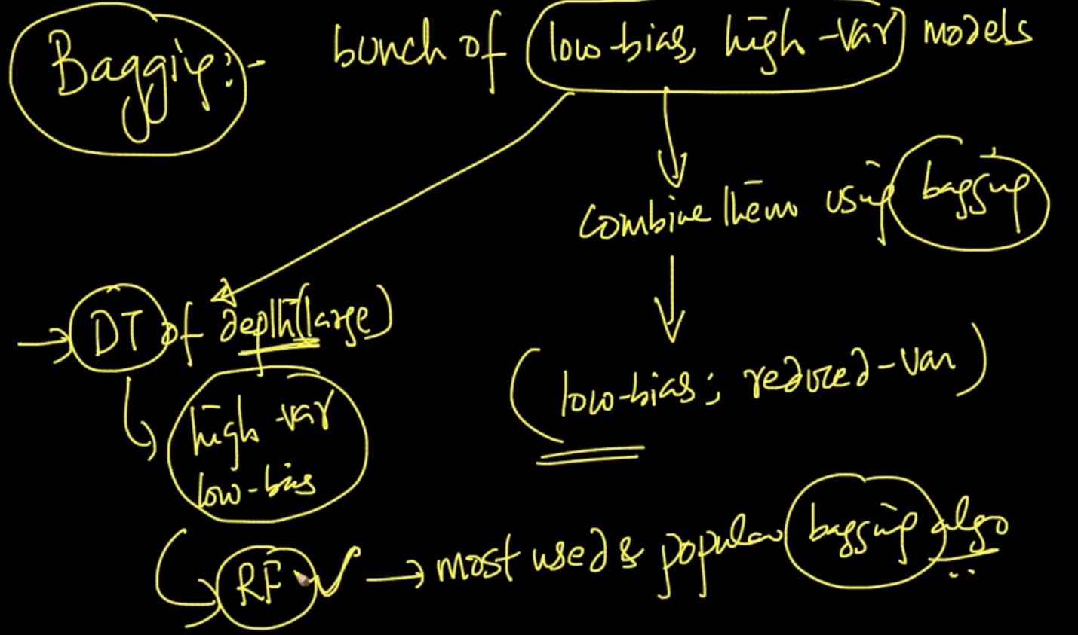

Decision Trees with large depth have high variance , low bias so when we apply Bagging on these models and combine them . It’s called Random Forests (RF) which is the most popular Bagging algorithm

# **RANDOM FOREST AND THEIR CONSTRUCTION**

Random Forests : “Random” comes from Random Bootstrap Sampling that we do in Bagging and “Forest” comes from Trees in Decision Trees

Random Forest = Decision Trees (as Base models) + Column Sampling (Feature Bagging)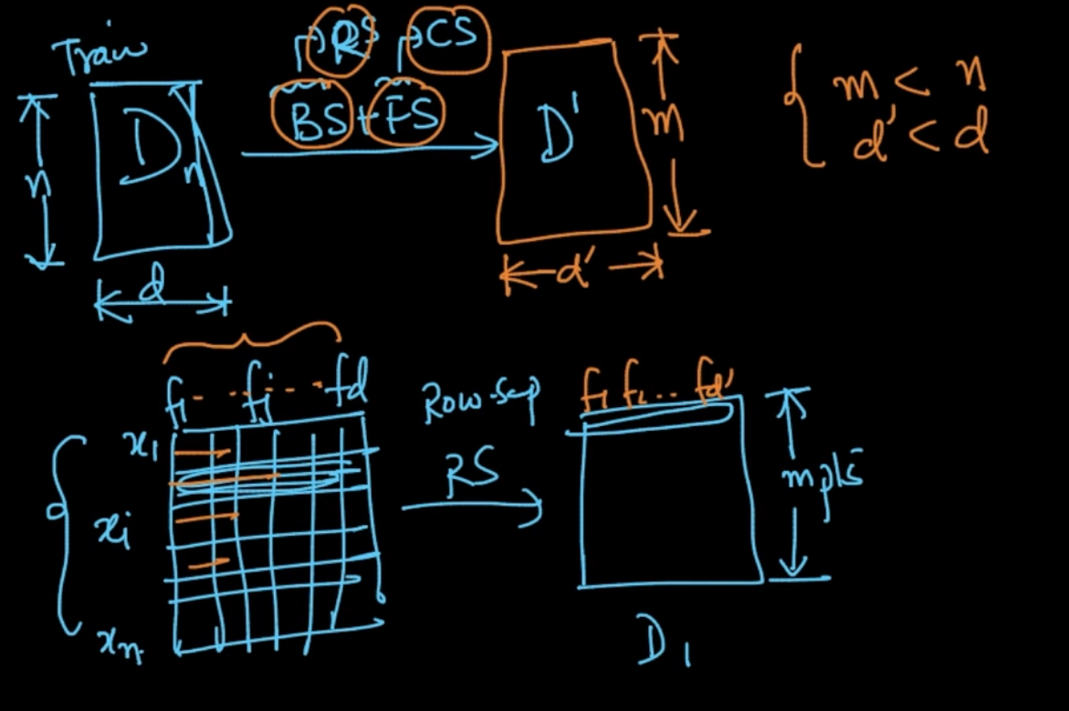

**Row Sampling/ Bootstrap Sampling** : Taking random points $x_{i}'s$ from our dataset. If we’ve n points and our Bootstrapped Sampling has m points then m < n

**Column Sampling/ Feature Sampling :** Taking random features from all our features. We don’t select all the features but some features randomly. If we’ve d dimensions in our actual dataset and d’ dimensions in sample then d’ < d

So we apply both these Sampling (Row Sampling + Column Sampling) in Random Forest

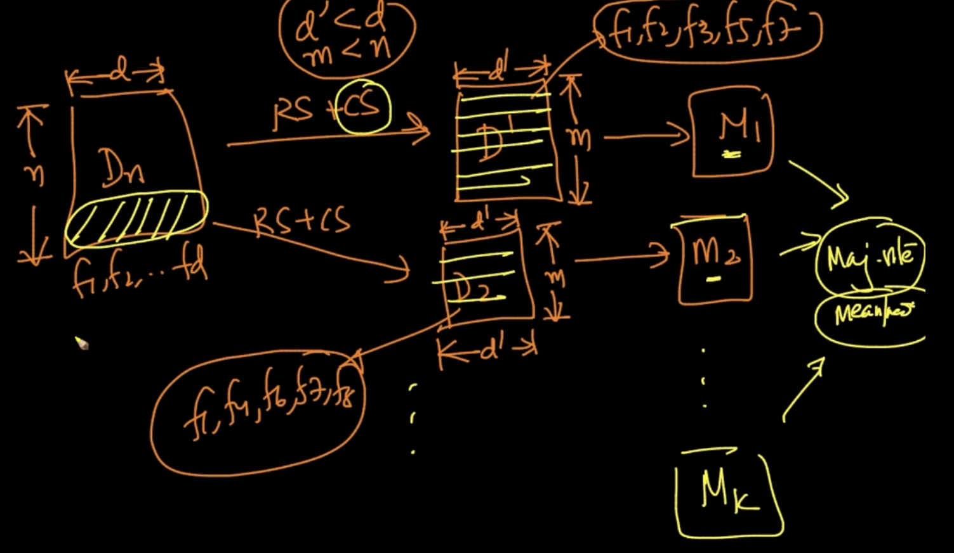

As it can be seen in $D_{1}$ we create model $M_{1}$ with m points and d’ features by applying Row Sampling + Column Sampling. Same for $D_{2}$ and further models

Note that in $D_{1}$ and $D_{2}$ both have different d’ as $D_{1}$ has d’ = {$f_{1},{ f}_{2}, f_{3},f_{5},f_{7}$} and $D_{2}$ has

d’ = {$f_{1},{ f}_{4}, f_{6},f_{7},f_{8}$} and m points are also there but they are also not same but randomly chosen. So both models $M_{1}$ and $M_{2}$ are very different and we take Majority Vote by combining results of all the models

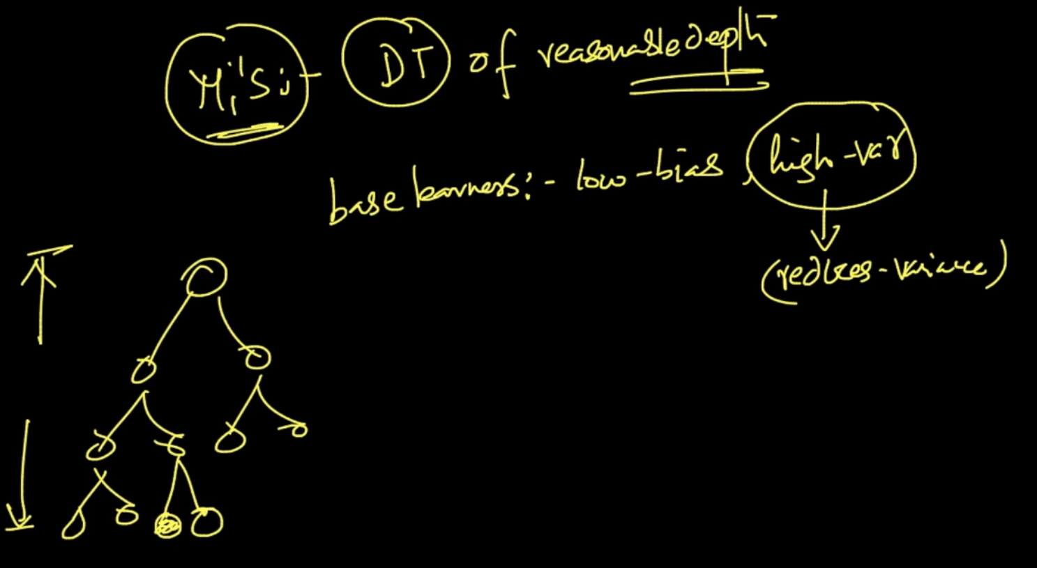

All our Base models ($M_{i}^{'}'s$) are Decision Trees of reasonable depth. We’ll have no problem if they’ve low bias and high variance since Aggregation function reduces Variance. We can use Decision Trees even if they’ve high depth or Overfitting because it means high variance which we can deal with.

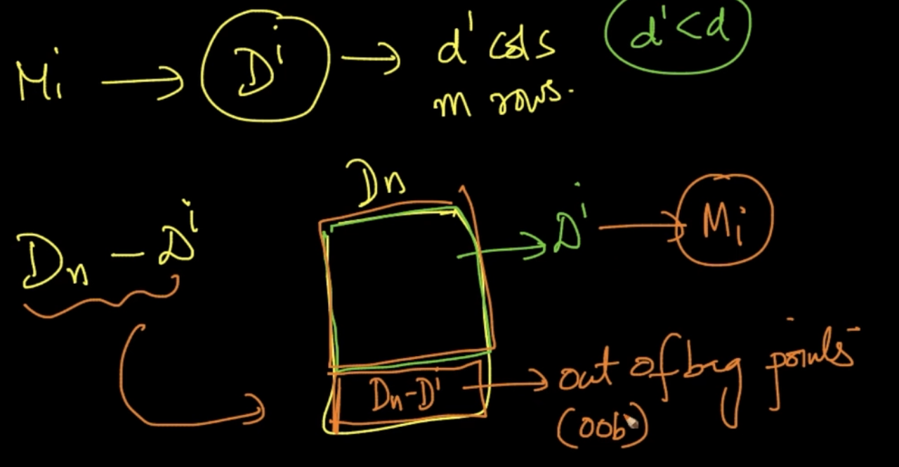

We want our models $M_{i}$ to be sensible . For that we do Cross Validation. We need CV data for that. Our model $M_{i}$ is created from $D_{i}$.So, $D_{n}-D_{i}$ which are also known as out of bag points can be used as CV data

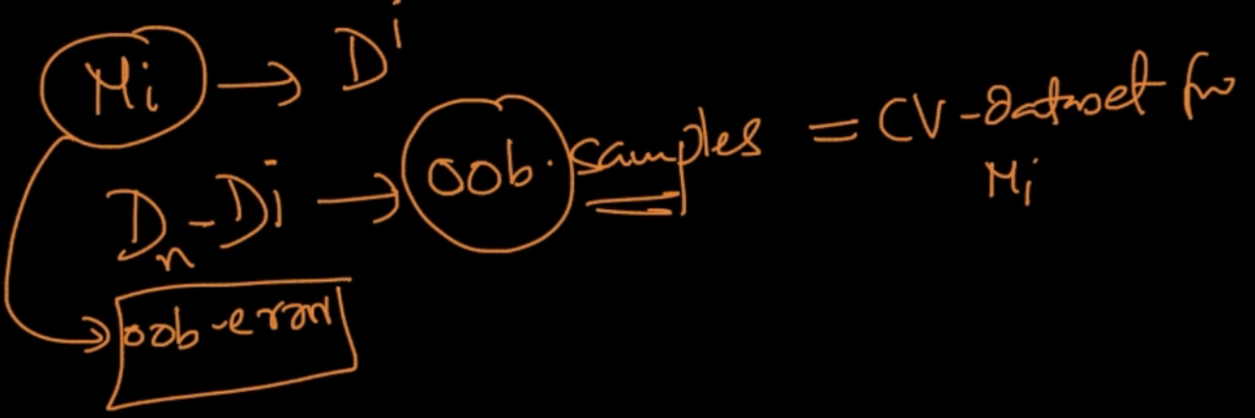

So lot of libraries have oob-error as a parameter

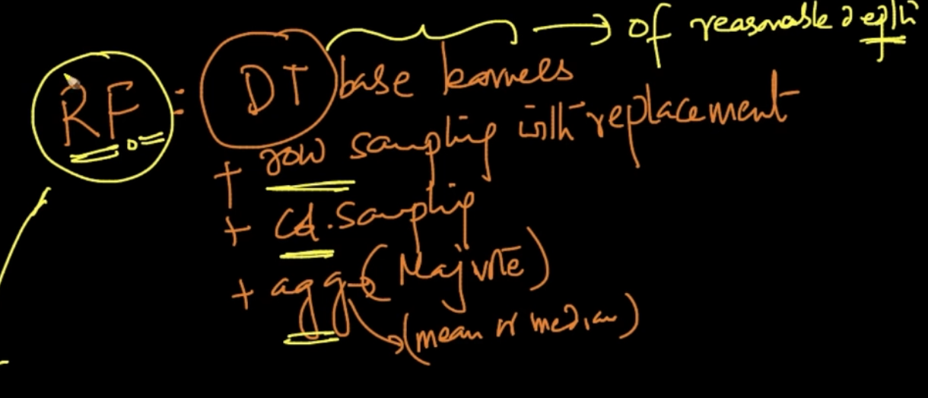

**Random Forest :** Decision Trees (Base Learners) of good depth + Row Sampling with replacement + Column Sampling + Aggregation (Majority vote/Mean or Median)

# **BIAS - VARIANCE TRADEOFF**

Random Forests have low bias because base learners ($M_{i}$) have low bias. As no. of models increase the variance decreases and vice versa.

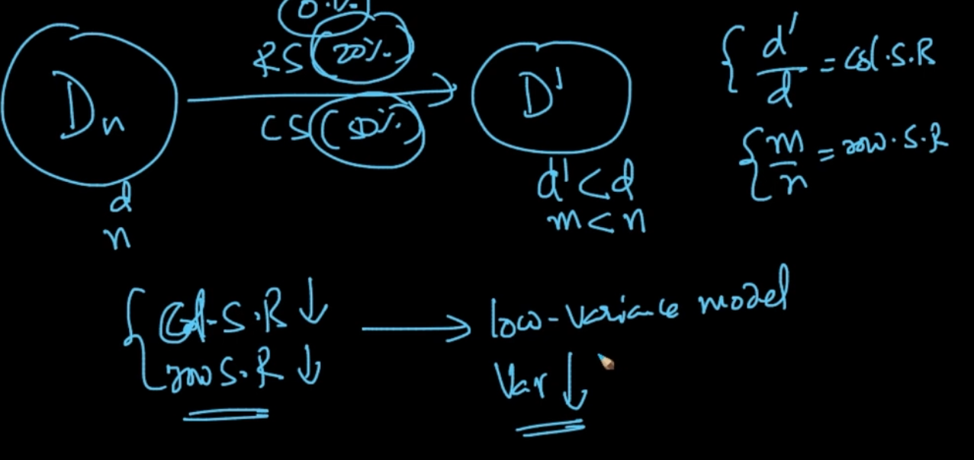

Column Sampling Rate (C.S.R) = $\frac{d'}{d}$ where d’ - Dimensions in Sampled columns, d- Total dimensions. Row Sampling Rate (R. S. R) = $\frac{m}{n}$ where m - Points in sample, n - Total points

When C.S.R and R.S.R are low we can have low variance model because each sample will have different Columns and Rows so they won’t be much co-related. We can fix RSR and CSR but we need to keep in mind that it isn’t too small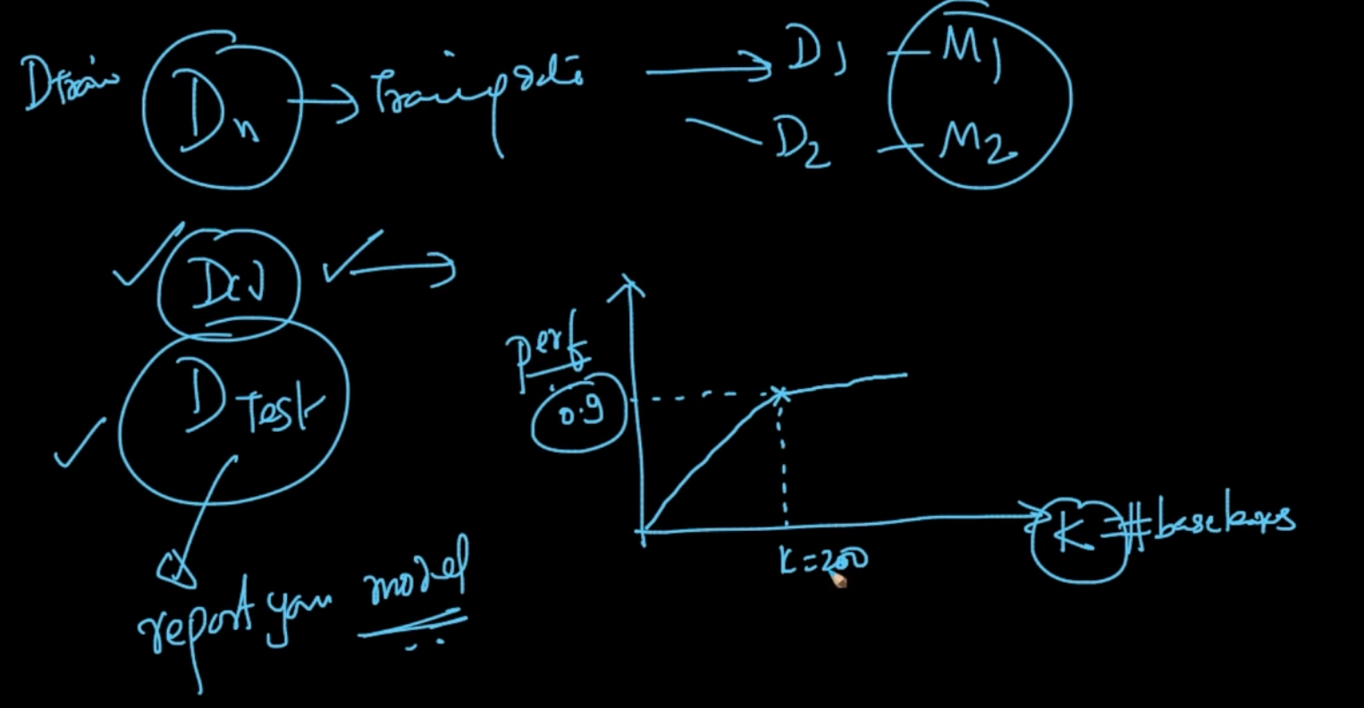

The most general practice is We use the Train Data , create Samples and create models

Our cross-validation data $D_{CV}$ is used to decide the ‘k’ - No. of base learners. It’s the most important parameter in Random Forests. We can decide the k using $D_{CV}$. k also helps in reducing variance as k $↑$, Variance $↓$

# **RUN-TIME AND TRAIN COMPLEXITY**

Train Complexity : O(n*lg(n) * d * k) where d-Features/Dimensions , k - No. of Base Learners. The amazing thing abour Random Forest is that they can be trained parallely

We create base models using samples as the samples are not dependent/linked with each other. We can train 1 model on 1 core and 2nd model on the another and so on

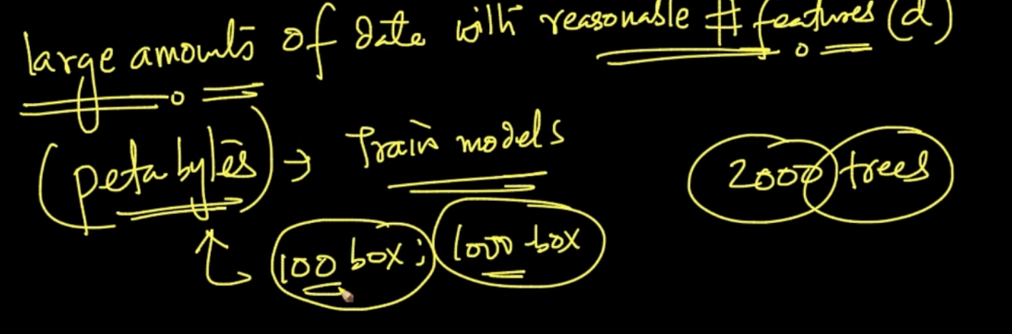

If we’ve large amounts of data then 100/ 1000 machines can be used parallely to train models. We can work with as large as 2000 Trees as well with this

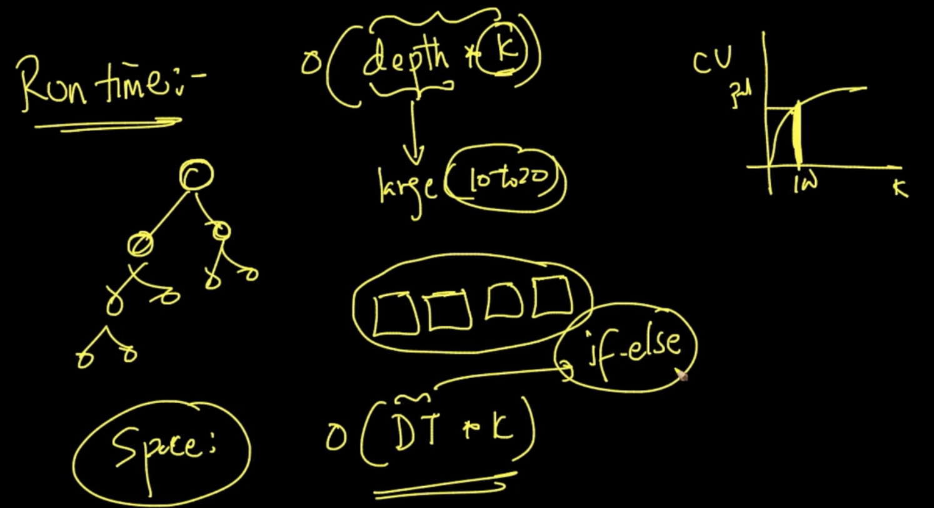

**Run-time complexity** : O(depth * k) which isn’t too much

**Space Complexity** : O(Decision Trees * k) . Decision Tree has to be stored which isn’t much as it’s just if-else conditions which are optimized by modern day compilers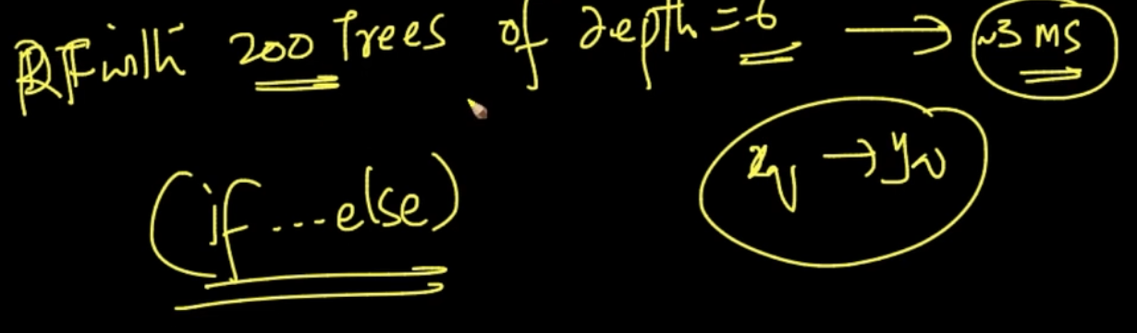

We can easily get result from a Random Forest with 200 trees of depth = 6 in 3 ms

# **EXTREMELY RANDOMIZED TREES**

We do the above things in Random Forest but in Extreme Trees we take a step further in addition to that. Let’s see how we do that

Extreme Trees :- In Decision Trees if we get real valued values in a feature we sorted them and tried all values to determine our Threshold $ζ$ but here what we do is we try out a random sample of possible value of let’s say 10 values to determine ζ

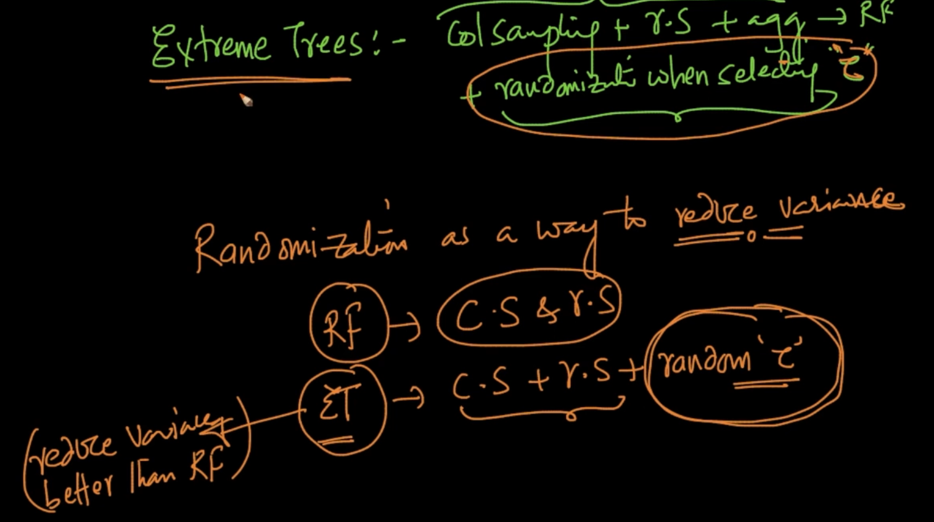

In Extreme Trees along with all the things of Random Forests we add one extra layer of Randomization when we select $ζ$ randomly. We reduced Randomization to reduce Variance so in Extreme Trees with added layer of Randomization it reduces Variance better than Random Forest

# **CASES IN RANDOM FORESTS**

As Random Forests are made with Decision Trees the cases are same as Decision Trees for Random Forests except 2 cases

1 ) Bias-Variance of Random Forest : Here we use deep-trees so to reduce variance we use

K - No. of Base Learners to reduce variance whereas in Decision Trees for handling Bias Variance we use the depth of Trees

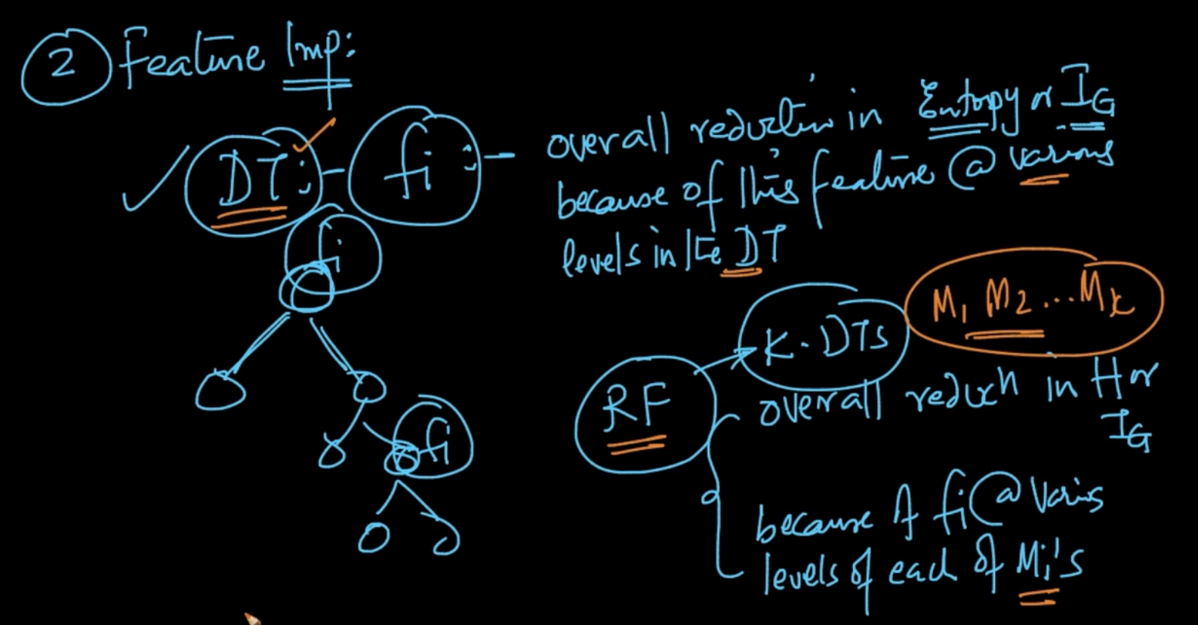

2 ) Feature Importance : In Decision trees we calculated reduction in Entropy or $I_{G}$ because of a feature at various levels in for deciding feature in DT

In Random Forest , we calculate overall reduction in Entropy or $I_{G}$ because of a feature at various levels of each base Learner/ Model $M_{i}'s$ as we deal with multiple DT here

# 

# **PART 2 : BOOSTING INTUITION**

**Bagging** : We did randomization (Column Sampling,Row sampling) + Aggregation to reduce variance

**Boosting** : We have low variance and high Bias and to reduce bias we additively combine to do it to keep variance low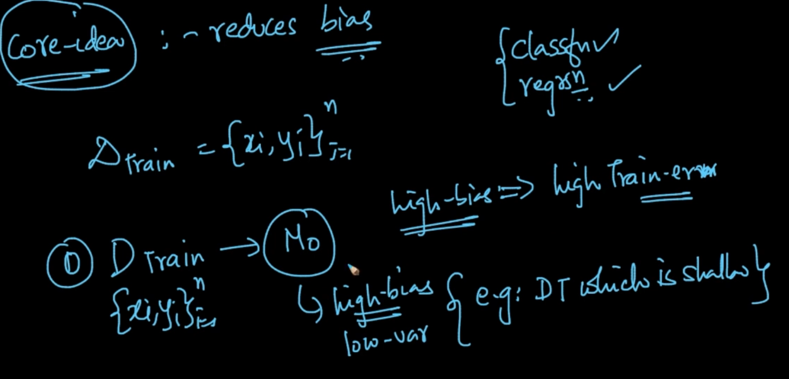

Our core idea is to reduce Bias. So let’s take down our steps

**Step 0** :- a) We’ve Train Data $D_{Train}$ we train a model $M_{0}$ with all the $D_{Train}$ and the model has high bias and low variance (Ex: A shallow DT (low depth)). High bias means high Train error.

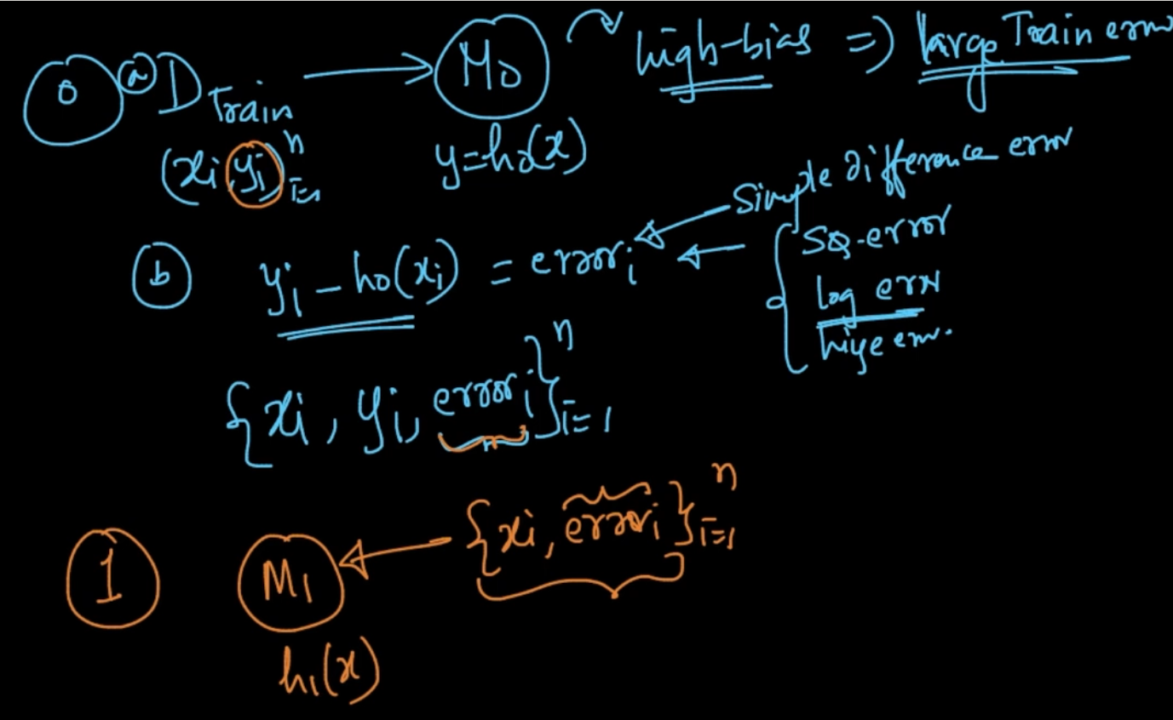

**Step 0** :- b) After making model $M_{0}$ we have y = $h_{0}(x)$. Since it’s a high bias model it has large Train error. We calculate ${error}_{i}$ = $y_{i}-h_{o}(x_{i})$ and store it

**Step 1** :- Now we create another model $M_{1}$ with ${\{x_{i},{error}_{i}\}}_{i=1}^{n}$ where we use ${error}_{i}$ as y instead of $y_{i}$ and we’ll get $h_{1}(x)$

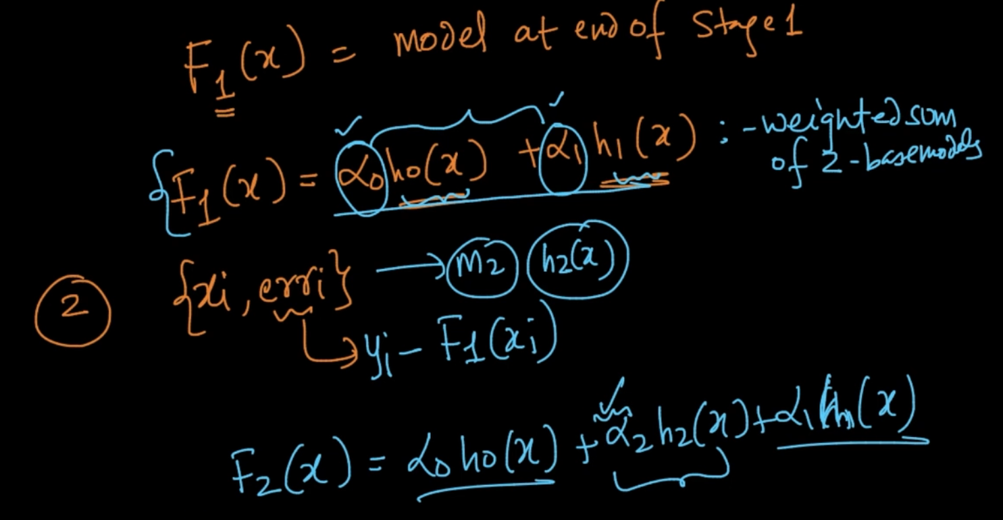

At the end of Step 1 we’ll have model $F_{1}(x)$ = $α_{0}h_{0}(x)$ + $α_{1}h_{1}(x)$. We can see it as a weighted sum of 2-base models .

Note : $α$’s are just coefficients . We’ll learn how to calculate them

**Step 2** : We create a model $M_{2}$ with ${\{x_{i},{error}_{i}\}}_{i=1}^{n}$ where ${error}_{i}=y_{i}-F_{1}(x)$ and we’ll get $h_{2}(x)$. Now we do $F_{2}(x)$ = $α_{0}h_{0}(x)$ + $α_{1}h_{1}(x)$ + $α_{2}h_{2}(x)$ and we’ll repeat this process

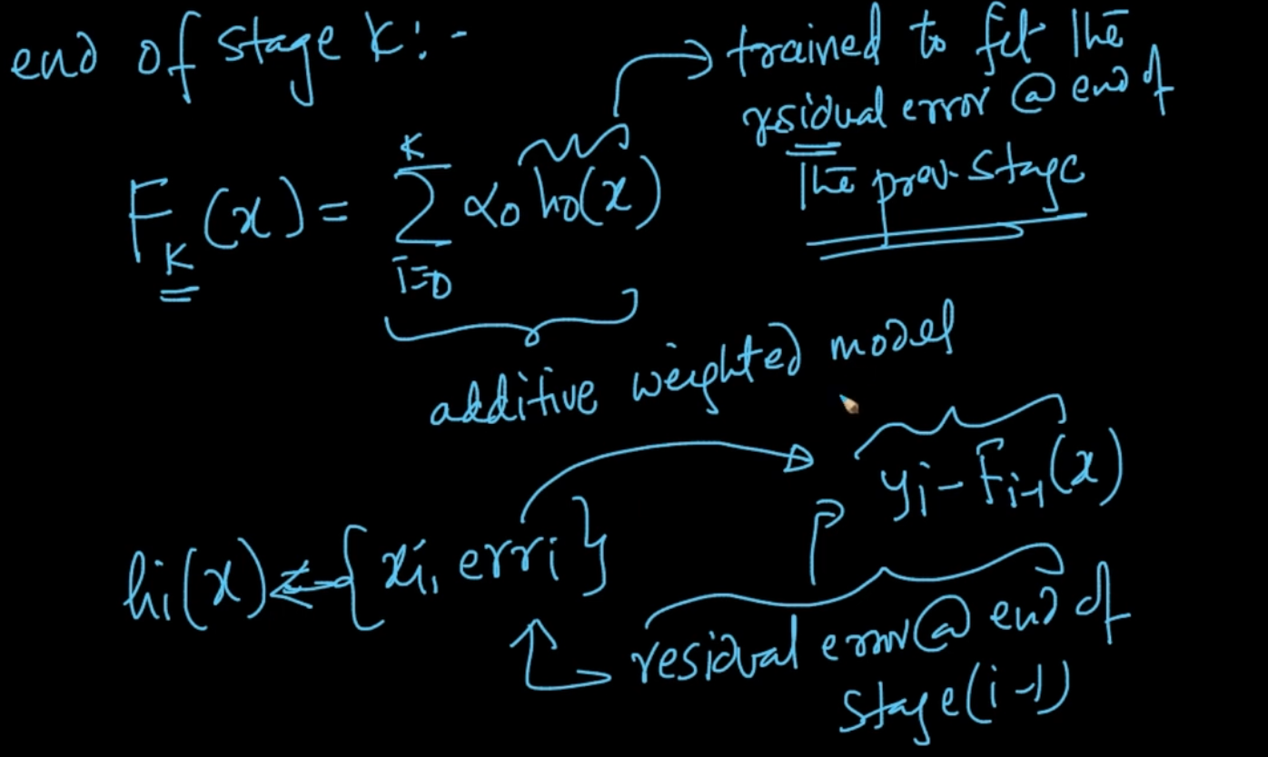

So at the end of k-steps we’ll have $F_{k}(x) =\sum_{i=0}^{k}{}$ ${α_{i}h_{i}(x)}_{}$ where h(x) is trained to fit residual error at the end of previous stage as $h_{i}(x)$ is trained on ${\{x_{i},{error}_{i}\}}_{}^{}$ and error is residual or left error at stage (i-1) or the previous stage => Mathematically writing: $y_{i}-F_{i-1}(x)$

Note : “k” is a hyper-parameter

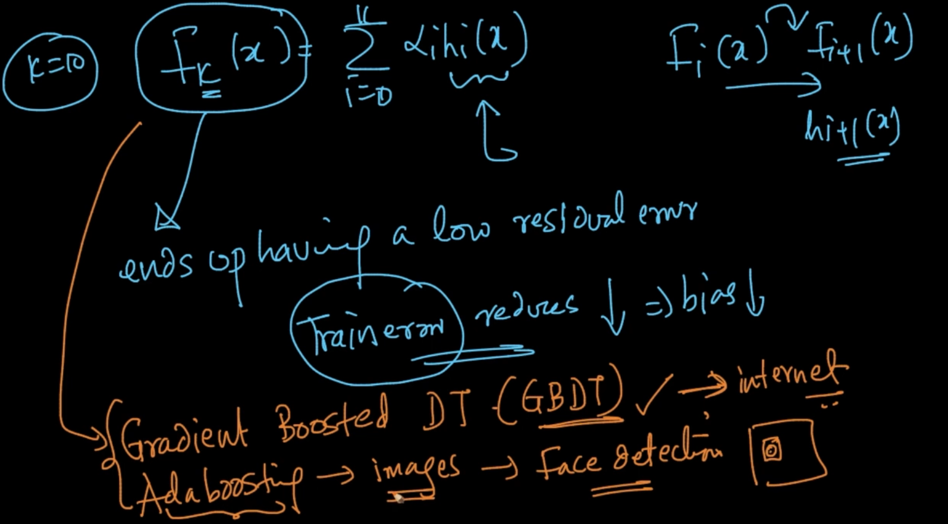

Our $F_{k}(x) =\sum_{i=0}^{k}{}$ ${α_{i}h_{i}(x)}_{}$ is basically summation of models and we end up with a low residual error model because our Training error is reduced. Why’s it reduced ? As we go from

$F_{i}(x)$ to $F_{i+1}(x)$ our Train error gets reduced because we are fitting $h_{i+1}(x)$ with the previous error so it’s getting reduced and as it reduced our bias also gets reduced

# **RESIDUALS, LOG-LOSS AND GRADIENTS**

Residual at end of stage ‘k’ => ${error}_{i}$ = $y_{i}-F_{k}(x)$ and a Model $M_{k+1}$ is trained with {$x_{i},{err}_{i}$}

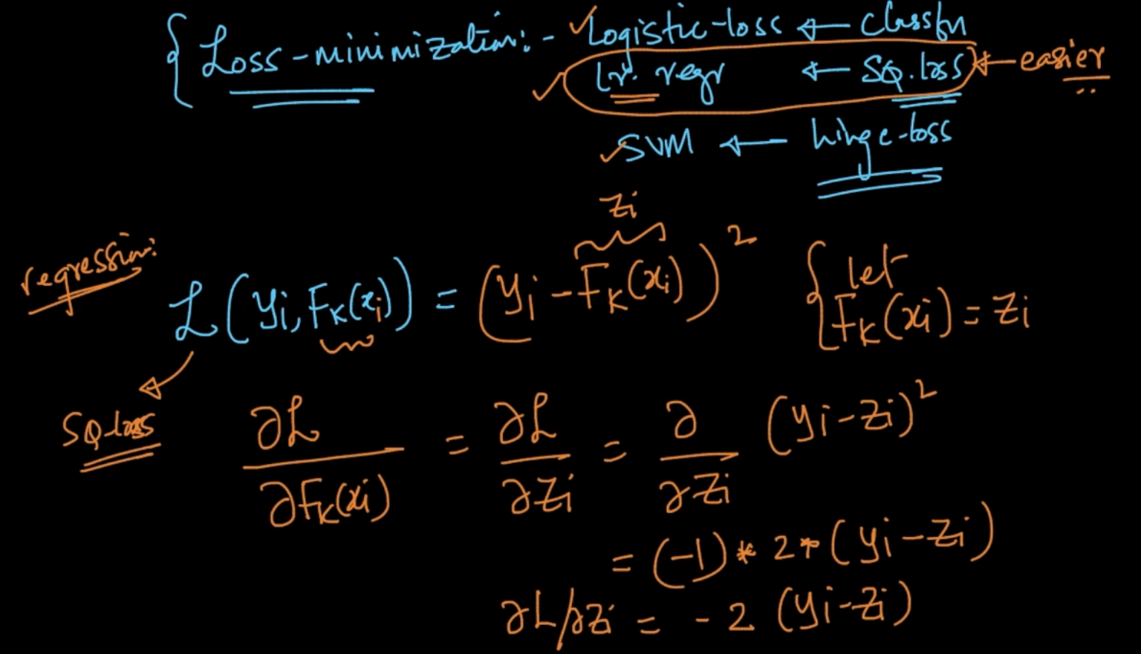

In ML, we try do Loss minimization as mentioned above for the algos like SVM, Logistic and Linear Regression. SO if we take example of Linear Regression our loss function

L($y_{i},F_{k}(x)$) = ${(y_{i} - F_{k}(x_{i}))}^{2}$ let $F_{k}(x)$ = $z_{i}$

So $\frac{δL}{δz_{i}}$ = $\frac{δ}{δz_{i}}$ ${(y_{i}-z_{i})}^{2}$ = - 2 * ($y_{i}-z_{i}$)

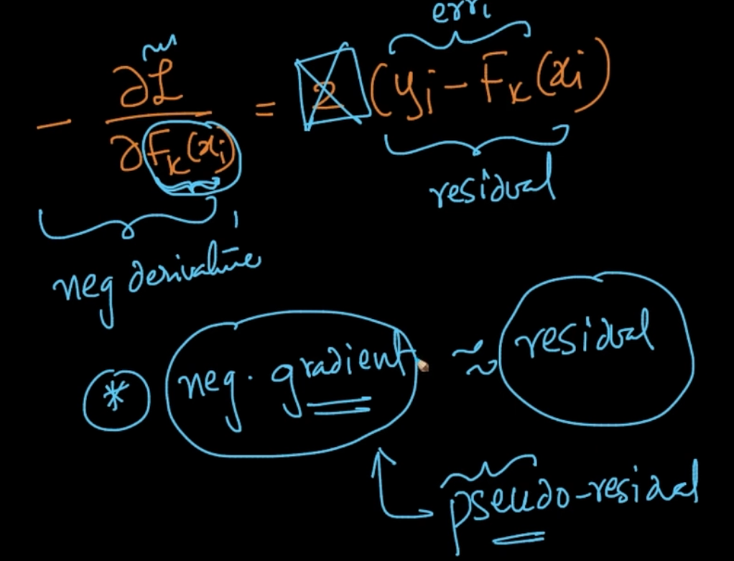

- $\frac{δL}{δ{F_{k}(x}_{i})}$ = 2 ($y_{i} - F_{k}(x_{i})$ so we can say that our negative gradient / derivative i.e differentiation of L w.r.t our function $F_{}$ of x at k stage i.e $F_{k}(x)$ $≈$ residual. Our negative grad can also be called pseudo-residual

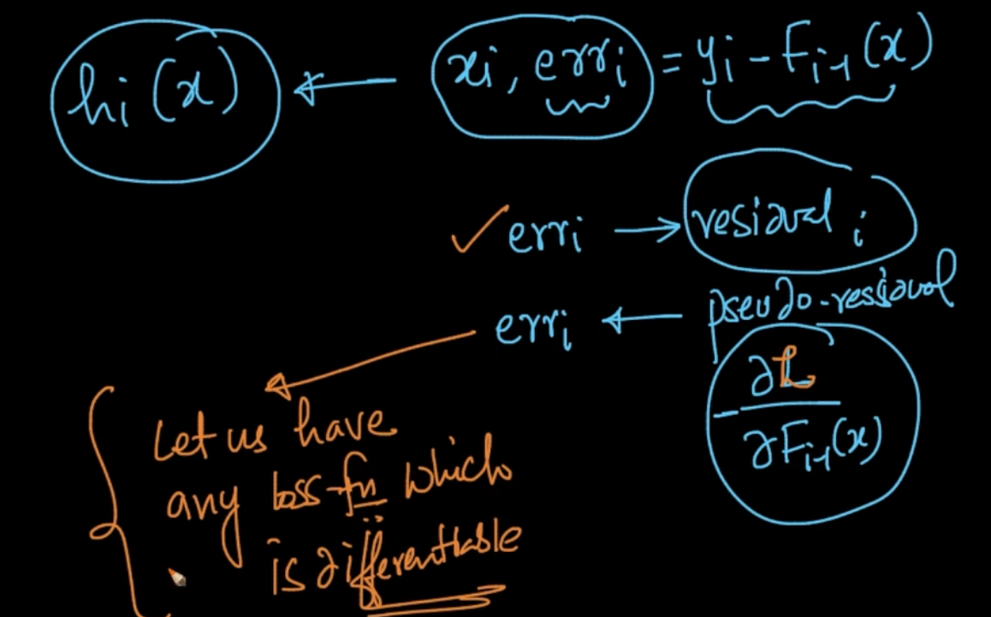

Our $h_{i}(x)$ is trained with $x_{i},{err}_{i}$ where ${err}_{i}$-> residual. Instead of residual we can have pseudo residual i.e - $\frac{δL}{δ{F_{i-1}(x}_{i})}$. The advantage of pseudo residual is that it can let us have any loss function which is differentiable since our pseudo residual is (- $\frac{δL}{δ{F_{i-1}(x}_{i})}$)

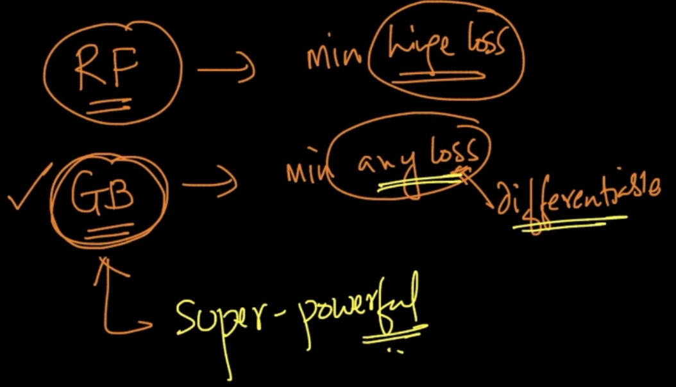

In Random forest we couldn’t minimize hinge loss but with Gradient Boosting we can minimize any loss which is differentiable. This makes Gradient Boosting extremely powerful

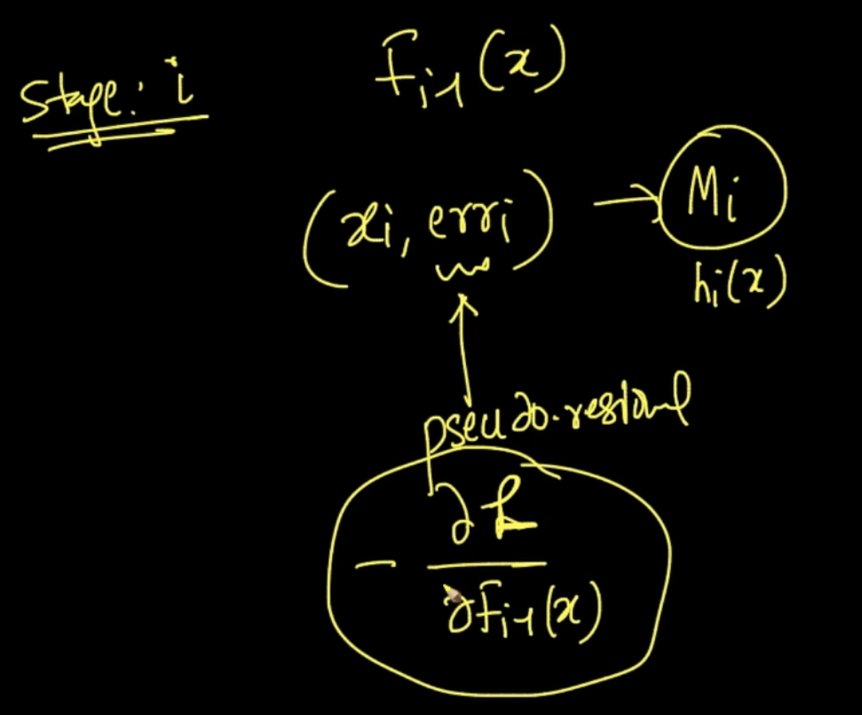

At stage i : We already have $F_{i-1}(x)$ we train our model $M_{i}$ i.e $h_{i}(x)$ with ($x_{i},{error}_{i}$) where error is pseudo residual => (- $\frac{δL}{δ{F_{i-1}(x}_{i})}$)

# **GRADIENT BOOSTING**

For initializing, let’s say we’ve a Squared loss. We need to find $γ$ such that it minimizes the loss function. In squared loss the $γ$ = mean($y_{i}$). So that’s how we are initializing our base/Zeroth model

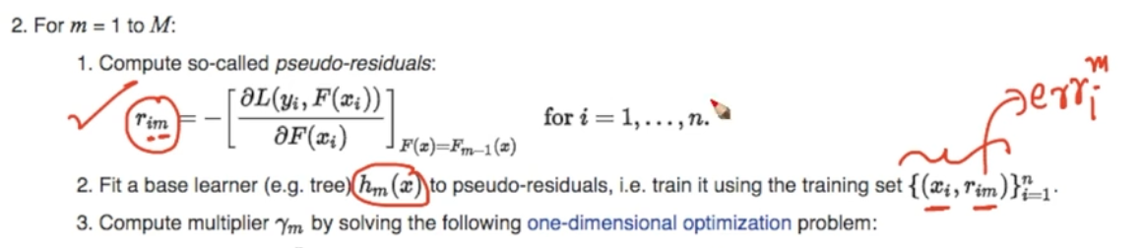

Now we calculate the Pseudo-residuals as mentioned. Our train data is ()



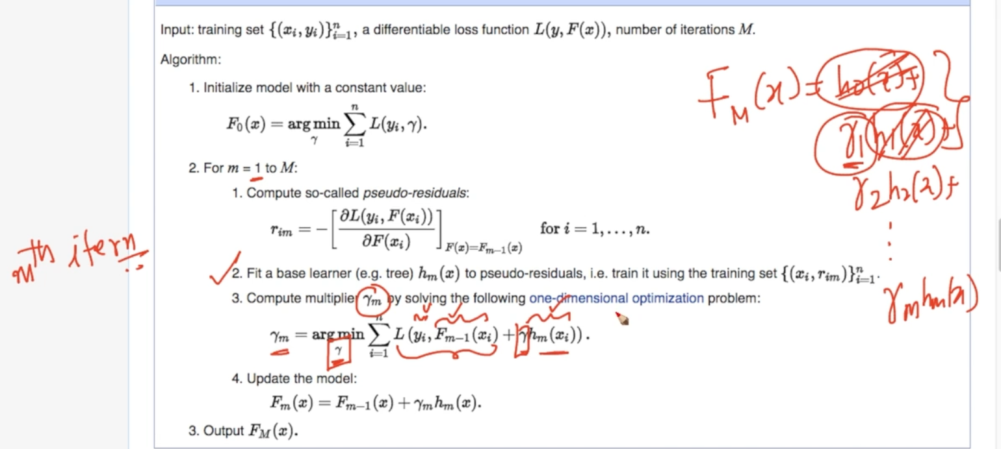

= + + …….

We calculate $y_{m}$ at m stage = $min$ $\sum_{i=1}^{n}{}L (y_{i},F_{m-1}(x_{i}))$ + $γh_{m}(x_{i}))$ we need to find $γ$ which minimizes this whole thing. Now we update our model. So our $F_{m}(x) =F_{m-1}(x) +γ_{m}h_{m}(x)$

Boosting is an additive technique.

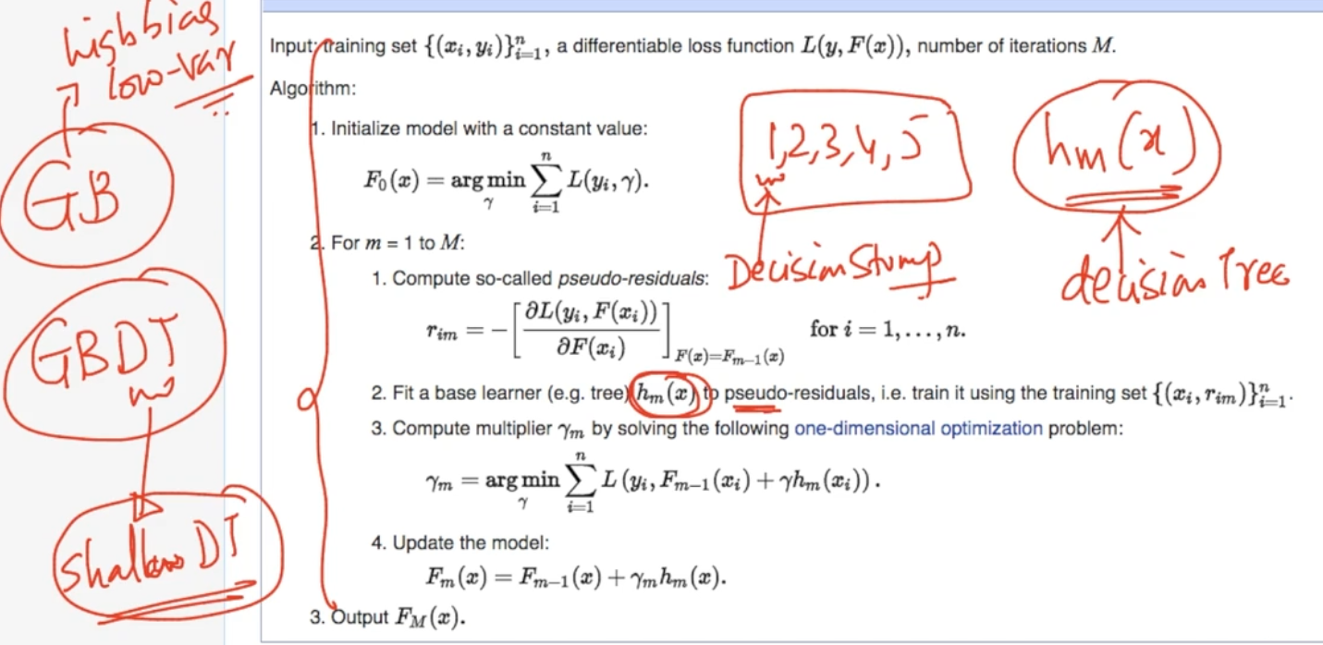

Our base learners $h_{m}(x)$ is a decision tree . In Gradient Boosting we need high bias and low variance so our trees are shallow here i.e of low depth

# **REGULARIZATION AND SHRINKAGE**

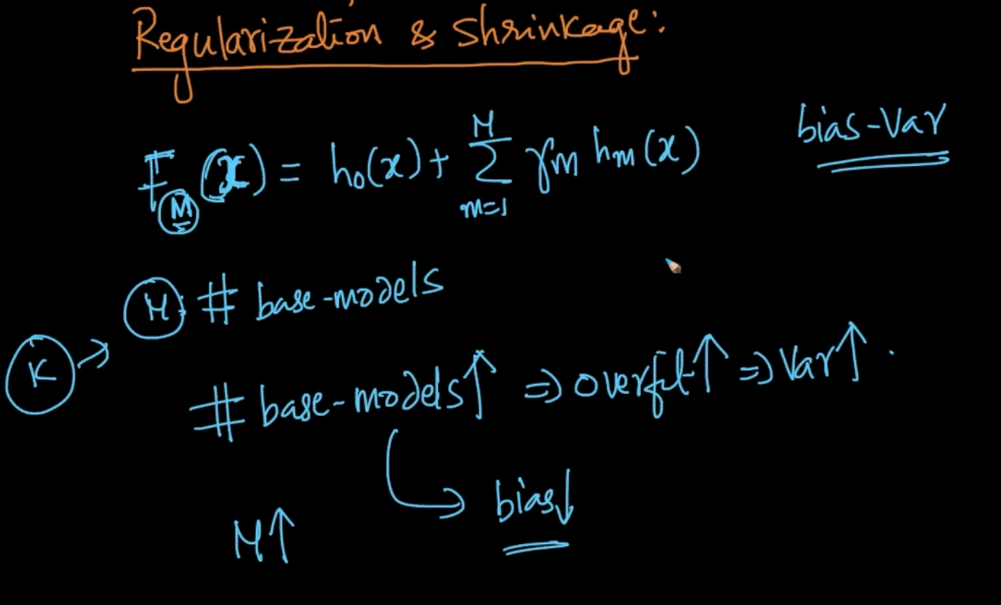

M - No. of Base Models and as they increase no doubt our bias gets decreased but our overfit $↑$ => variance so there’s a nice idea called shrinkage to deal with this

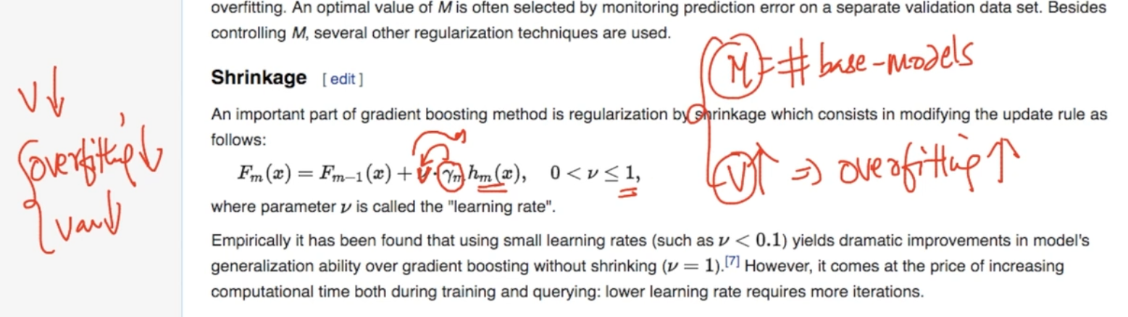

$F_{m}(x) =F_{m-1}(x) +{ν * γ}_{m}h_{m}(x)$ so we add $ν$ called as “learning rate”. It is also a parameter

As we can see if it’s small then it reduces the weight of $γ_{m}h_{m}(x)$ so our chances of overfitting also decreases. So we can imply that as $ν↓$ => overfitting , variance $↓$ and as

$ν↑$ => overfitting $↑$. In Gradient Boosting M and $ν$ are hyper-parameters

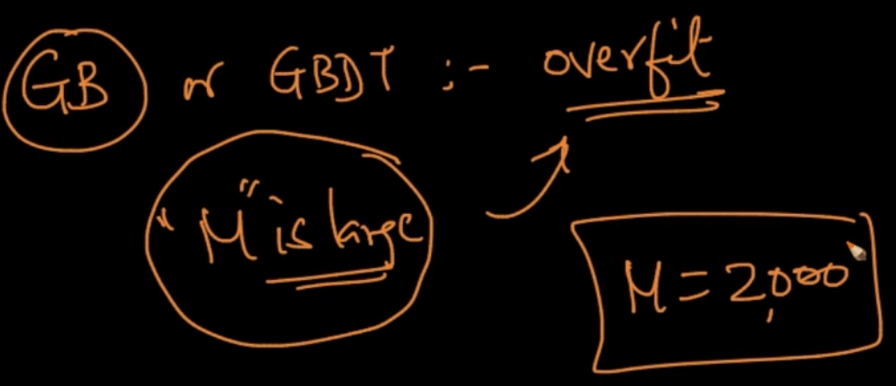

It’s very common in Gradient Boosting that people overfit by taking large M

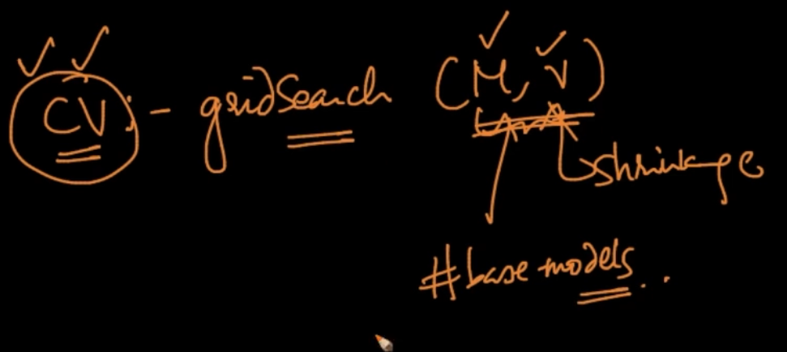

Always do Cross Validation i.e GridSearch to get the best M and $ν$. Not only here but in every model

# **TRAIN AND RUN TIME COMPLEXITY**

**Train time complexity :** O (nlogn *d * M) where O(n * logn ) is Time complexity of DT and M is no. of base learners. Random Forest was parallelizable as each models were separate from other model but GBDT is not easy to parallelize as it’s a very sequential model

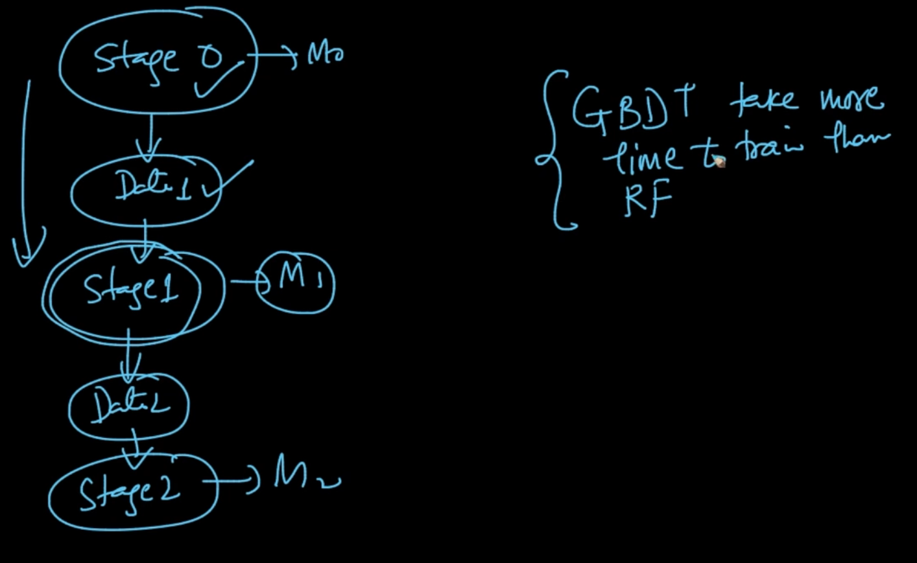

As we can see in Gradient Boosting we train model $M_{0}$ at stage 0 and from the data obtained we train model $M_{1}$ and so on . Since it’s not parallelizable and sequential it takes more time than Random Forest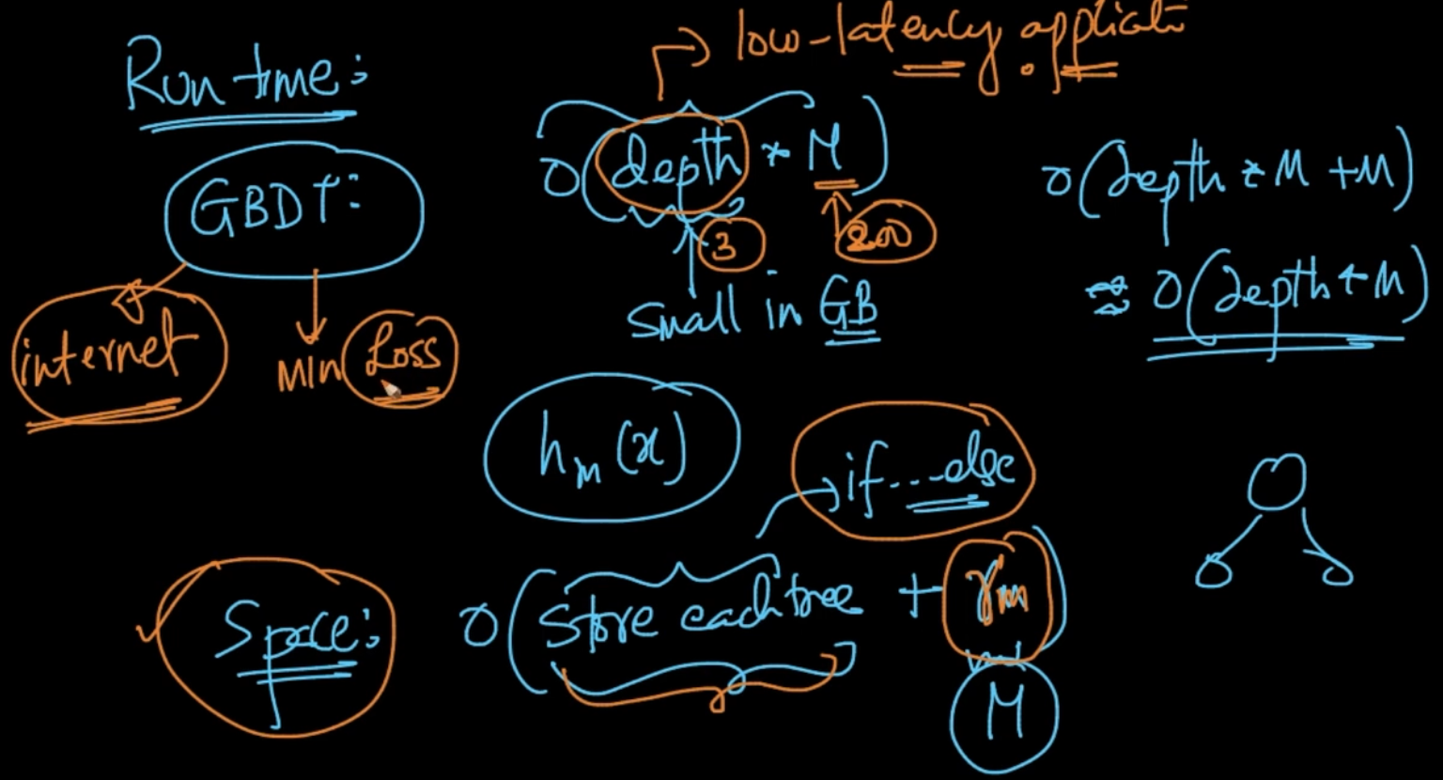

**Run Time Complexity:** O(depth * M) but one of the interesting thing is that depth is small in GB so it makes extremely fast and can be used in low latency applications

**Space Complexity** : O(Store each tree + $γ_{M}$) and storing each tree is just like Random Forest but we also need to store the $γ_{M}$ for each base learner

**XGBOOST**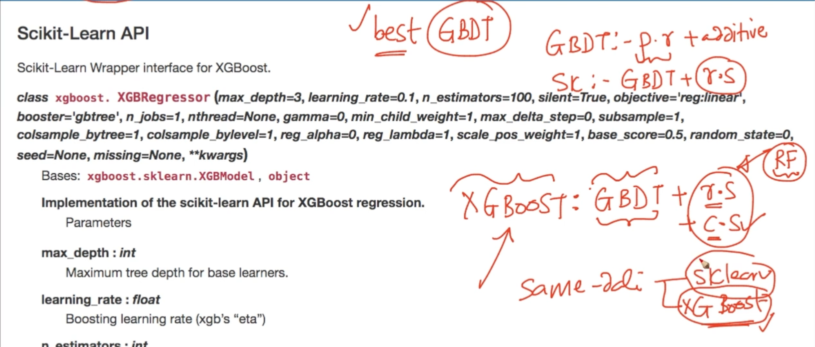

**XGBoost :** Here it takes all the great things mentioned from Gradient Boosting + It also takes great things of Random Forests like Row Sampling and Column Sampling

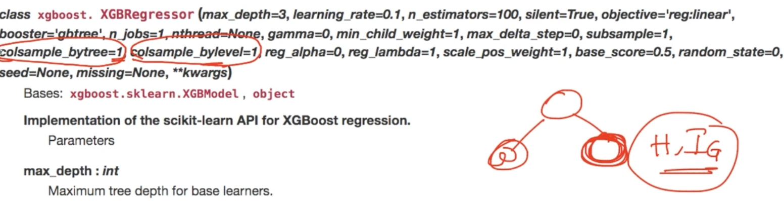

The most important thing in XGB is that you can sample columns by trees i.e we don’t need all features for making a tree. We can just use some random columns as well

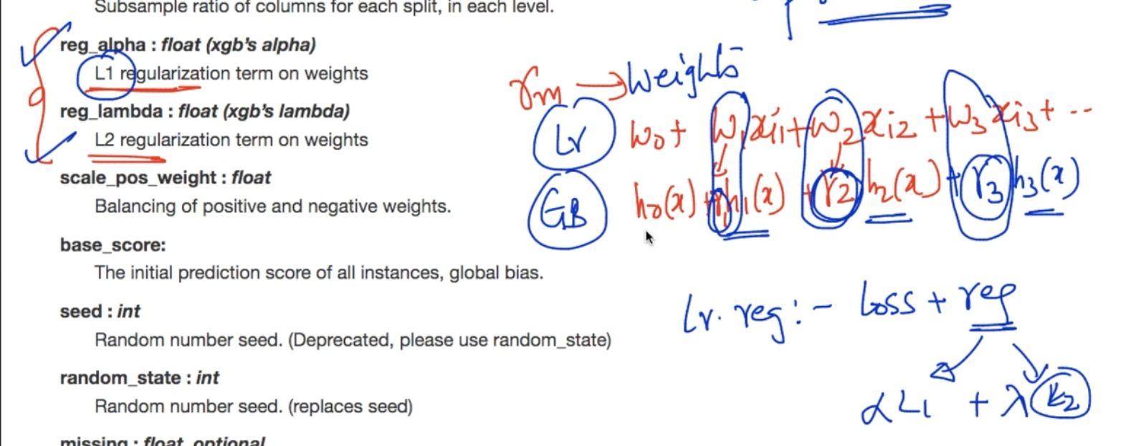

In Linear Regression : ${w_{0}+w}_{1}x_{1}+w_{2}x_{2}+.....$

In Gradient Boosting : $h_{0}(x)+γ_{1}h_{1}(x) +γ_{1}h_{1}(x)$…...

We did L1/ L2 regularization on weights . We can do that here as well since we can consider our $γ's$ as weights and perform Regularization

# **ADABOOST**

We’ve dataset D1 as shown we train a DT with depth = 1 i.e with 1 hyperplane

When we create our first model $h_{1}(x)$ we also get weight $α$ based on errors.We get 3 erroneous points as shown above. We give it more weight i.e upsample and that will be used as a dataset in 2nd model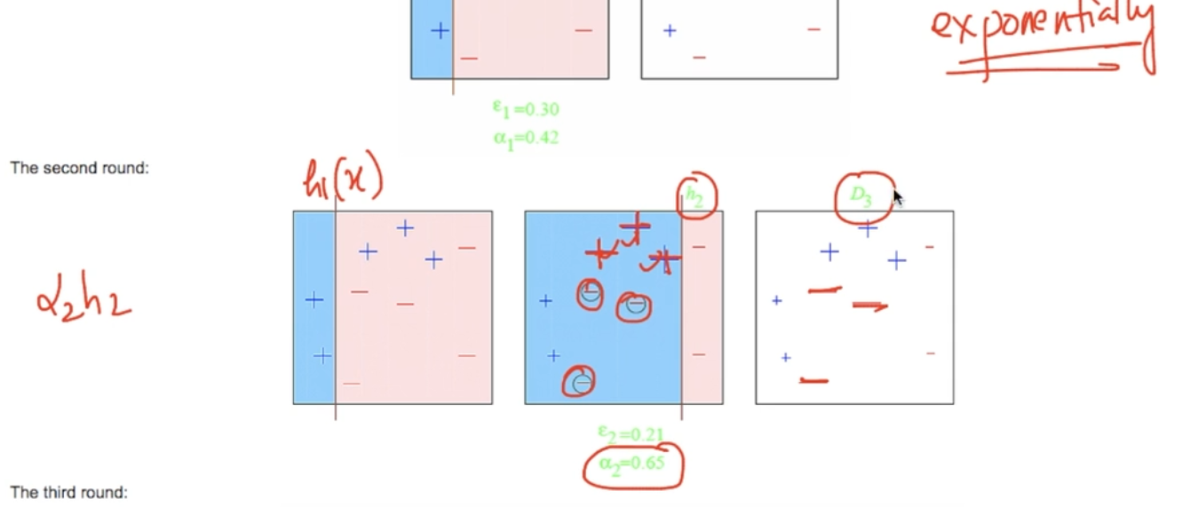

Now we create a model $h_{2}$ separating the upsampled points correctly. We get $α_{2}$ as well

Now also 3 error pts. We’ll upsample it

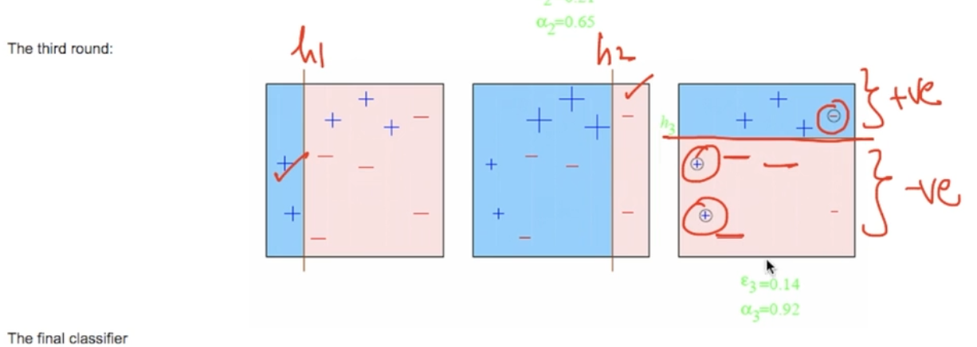

Now we train our model $h_{3}$. It has 2 error points but it’s taken care by $h_{1}$

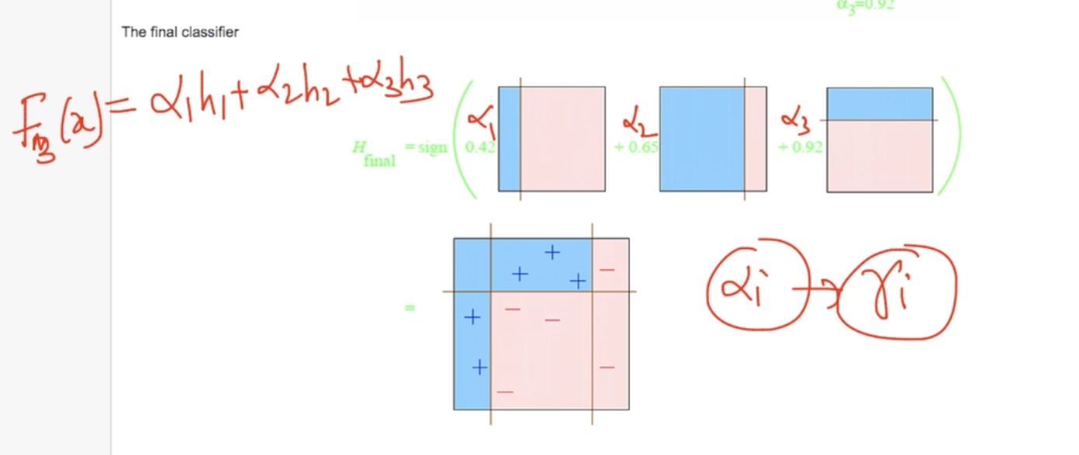

So our final model is made by combining all the 3 models. Our final model

$F_{3}(x)=$ $α_{1}h_{1} + α_{2}h_{2} + α_{3}h_{3}$

In AdaBoost, our model is adapting to the errors of the previous model and more importance is given to the points which are misclassified.This is core of Adaboost

# **STACKING MODELS**

We train m-models and each model is parallel and independent from each other

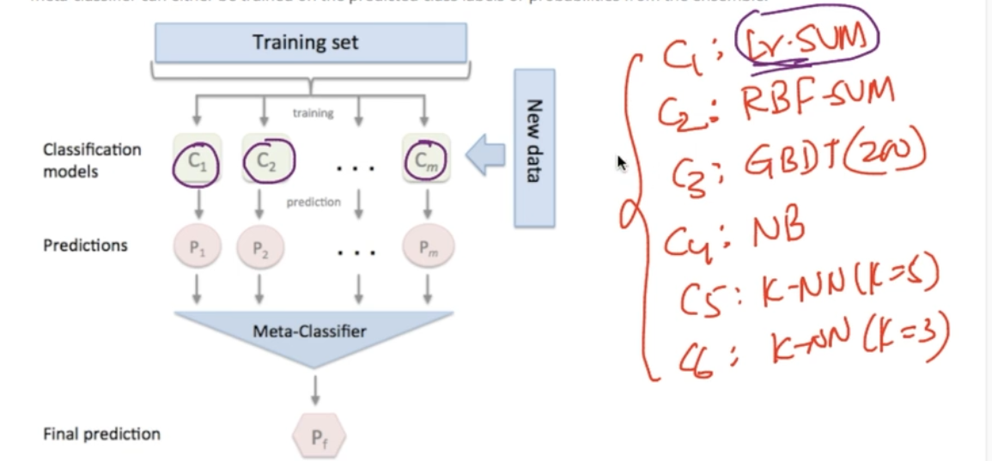

As we can see each model is different from another one and the more different it is the better output

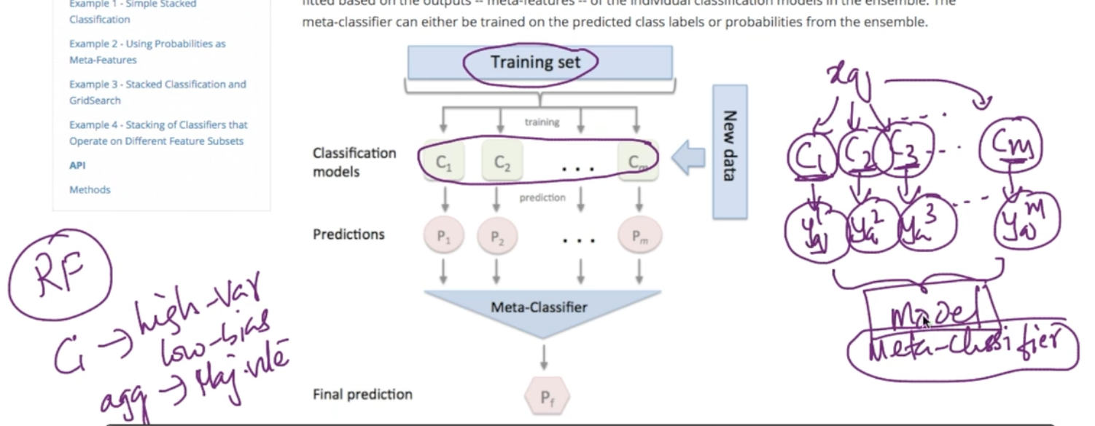

So we have $x_{q}$ and we train m-models i.e $C_{1},$ $C_{2},$ $C_{3},$…. $C_{m}$ and we get some ${y_{q}}^{}$ from each of them i.e $y_{q}^{1},$ $y_{q}^{2},$ $y_{q}^{3},$... $y_{q}^{m},$ we combine them and put it into a model called meta-classifier. Remember in Random Forests we trained multiple models that had high variance and low bias .We combined them and used majority vote to reduce variance but here all the base models C are well-tuned with good bias-variance tradeoff and our Meta-Classifier is also an ML model like Logistic Regression or any other instead of aggregation function like majority vote

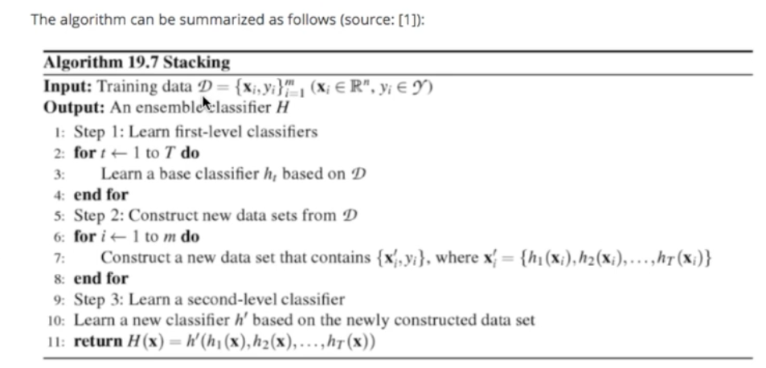

**Step 1:** We have dataset D as shown we train T- number of classifiers h and each classifiers have proper bias variance tradeoff .

**Step 2 :** We construct new3 dataset D’ where {$x_{i}^{'} , y_{i}$} where $x_{i}^{'}=$ { $h_{1}(x_{i})$, $h_{2}(x_{i})$,..... $h_{T}(x_{i})$}

**Step 3**: Now all the new Dataset D’ is applied to a second-level (Meta) classifier and

$y_{q}$ = h’($h_{1}(x_{i})$, $h_{2}(x_{i})$,..... $h_{T}(x_{i})$)

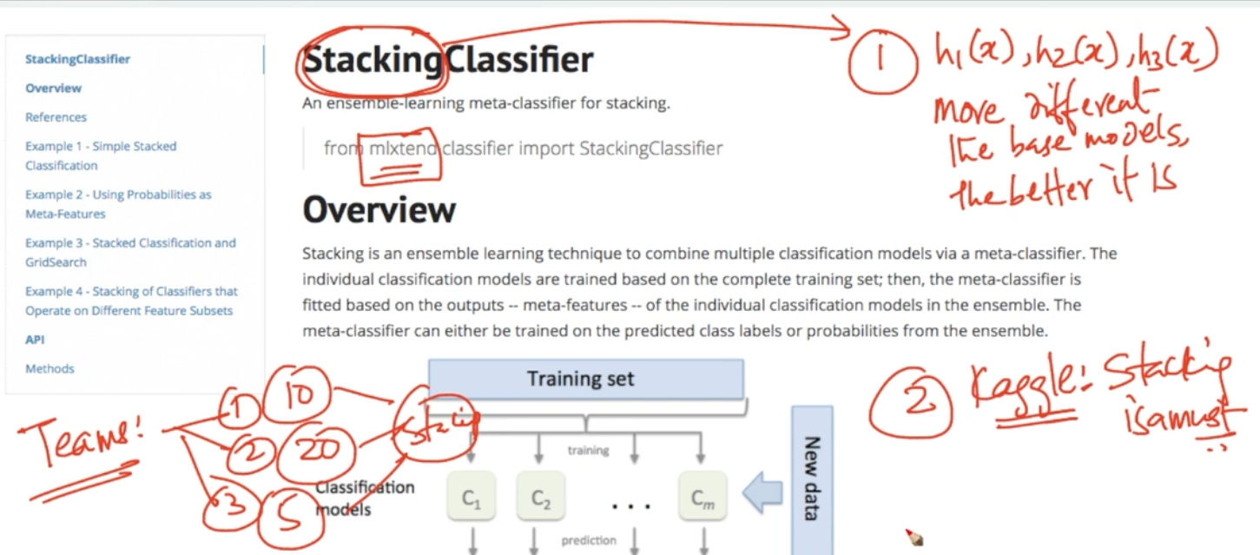

1 ) The different each base model is the better

2 ) Kaggle : Stacking is a must in Kaggle. In a team one can work on 10 classifiers ,other on 20 and then they can stack it but in real world it’s seldom used as it has huge Train and Runtime

# **CASCADING CLASSIFIERS**

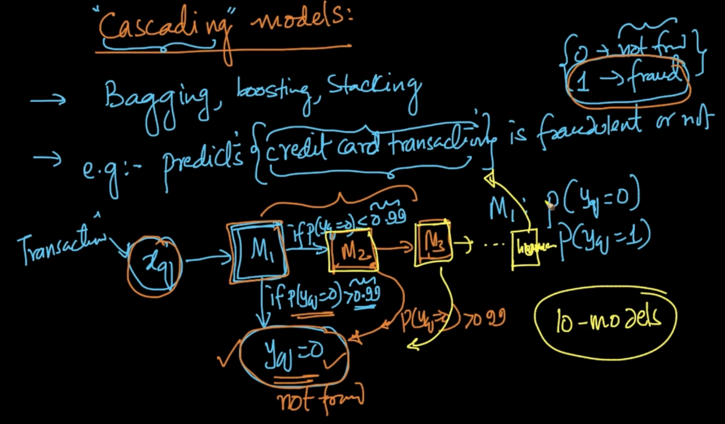

We are taking the above example of Credit card fraud detection

We’ve $x_{q}$ we train a model $M_{1}$ with that . Our model gives P($y_{q}=0$) or P($y_{q}=1$)

So after $M_{1}$ if P($y_{q}=0$) > 0.99 we say $y_{q}=0 ($ not fraud) but if P($y_{q}=0$)< 0.99 we train another model $M_{2}$ and there if P($y_{q}=0$) > 0.99 then $y_{q}$ = 0 . We repeat this process and cascade models and after that if it comes < 0.99 then a human will determine the transaction

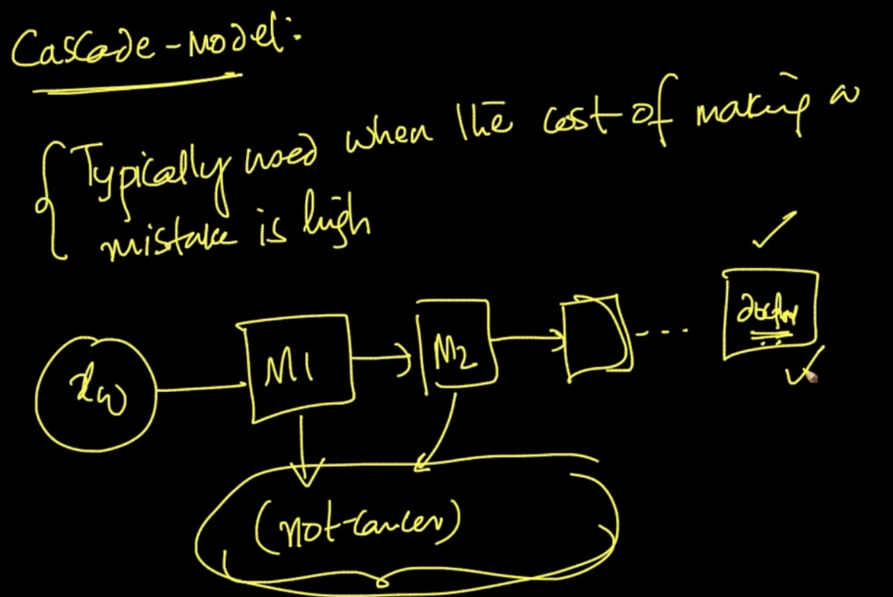

They are used when cost of making mistake is high. Ex : In Medical domain. Most of cases where algos can take care whether they are cancerous or not

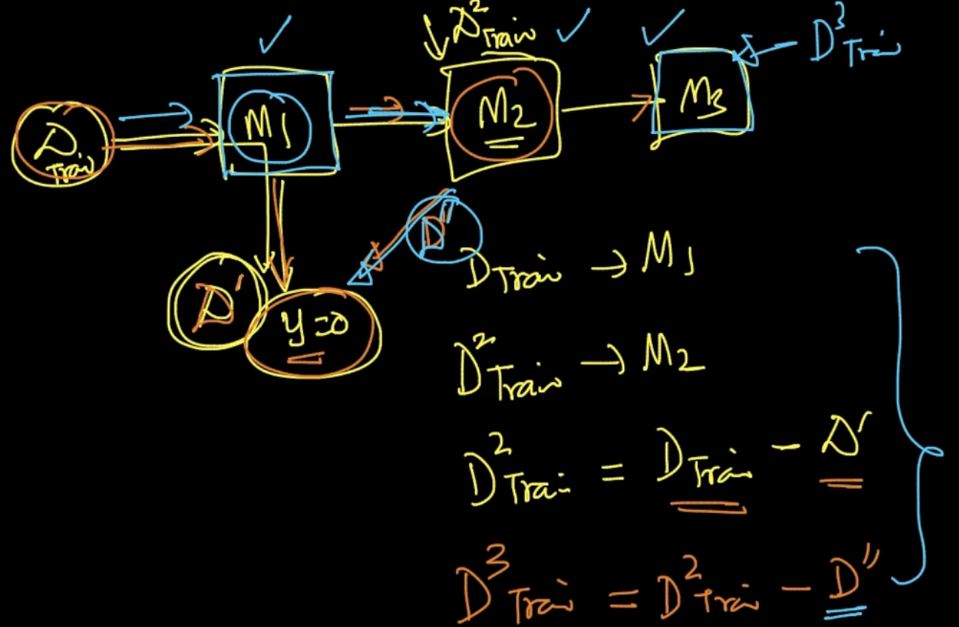

We use $D_{Train}$ for $M_{1}$. D’ points are gone into y = 0 after $M_{1}$. Now we train our model $M_{2}$ on $D_{Train}^{2}$ where $D_{Train}^{2}$ = $D_{Train}^{}$- D’ and same theory is applied for further models

We need to keep this in mind . We are not supposed to use already gone dataset again

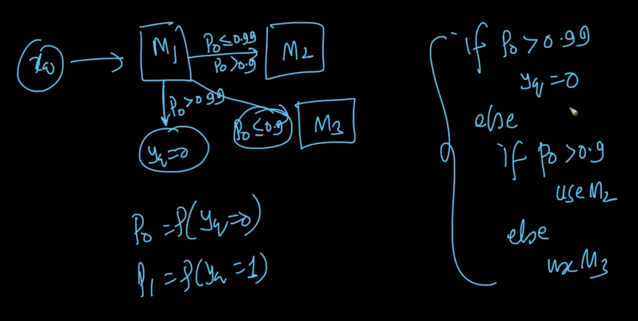

A cascade model can also be like this . See the multiple if - else conditions above

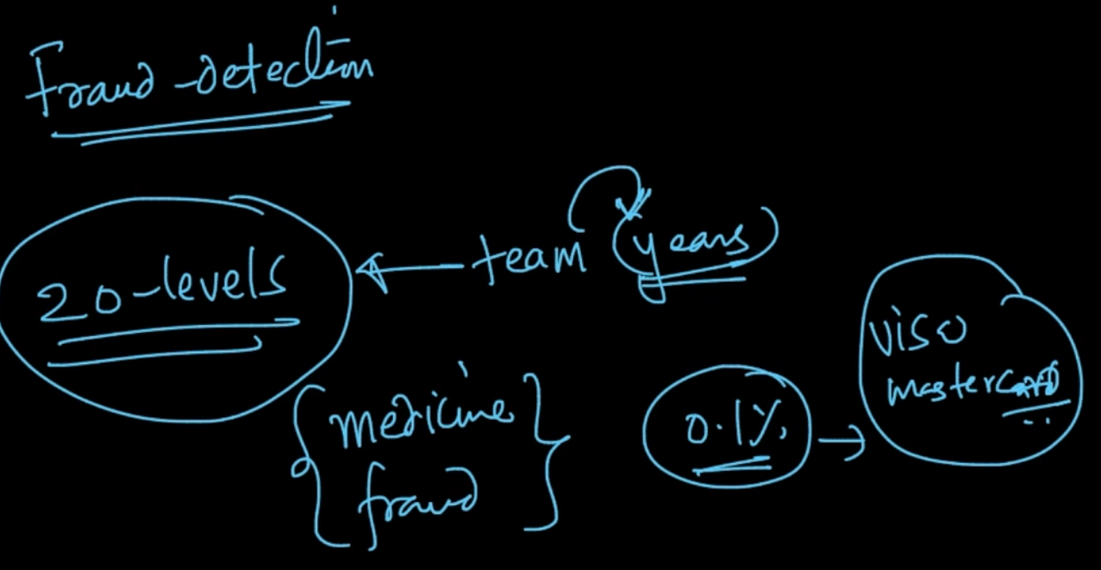

If a team is taking years then even 20 levels of cascading blocks are added to it

Cascade models are used when cost of making mistakes is high